Design and Analysis of Algorithms
Lecture 1
Introduction to Algorithms
What is Algorithm?
An algorithm is a finite sequence of well-defined steps used to solve a problem or perform a computation.
Formal Definition
An algorithm is a step-by-step procedure that takes input, processes it logically, and produces output to solve a specific problem.
Example
Problem: Find the sum of two numbers Algorithm:
- Start
- Input two numbers
- Add the numbers
- Display the result
- Stop
Real-Life Examples of Algorithms:
Algorithms aren’t just in computers—they’re all around us in daily life. Some examples:
- Recipe for cooking food: Follow steps like boil water → add ingredients → cook → serve.
- Withdrawing money from an ATM: Insert card → enter PIN → choose amount → collect cash.
- Logging in to an email account: Open email → enter username → enter password → click login.
All these follow a clear sequence of steps, which is exactly what an algorithm is.
Why Do We Need to Study Algorithms?
- Efficiency:
Algorithms help solve problems faster and use less memory.
Example: If you have 1000 numbers to sort, a good sorting algorithm like Merge Sort will sort them much faster than checking each number randomly.
- Problem-Solving Skills:
They teach logical thinking and step-by-step reasoning.
Example: Solving a maze step by step is like following an algorithm—you try one path, backtrack if it’s wrong, and eventually find the exit.
- Foundation of Programming:
Every program is an implementation of an algorithm.
Example: A calculator app follows an algorithm: take numbers → perform operation → show result.
- Optimization:
Algorithms help pick the best solution among many.
Example: If you want the shortest route on Google Maps, the app uses algorithms to find the fastest path instead of trying all possible routes.
Real-World Applications of Algorithms:
Algorithms are everywhere in daily life. They are used in:
- Search Engines: To quickly find relevant information on the internet (like Google).
- Banking Systems: For secure transactions, ATM operations, and fraud detection.
- GPS Navigation: To find the fastest route from one place to another.
- Artificial Intelligence: For tasks like speech recognition, recommendations, and self-driving cars.
- Data Analysis: To process large amounts of data and find patterns or insights.
What Kinds of Problems Are Solved by Algorithms?
Algorithms solve computational problems, such as:
Numerical Problems
- Sorting numbers
- Finding maximum/minimum
- Mathematical calculations
Searching Problems
- Linear search
- Binary search
Sorting Problems
- Bubble sort
- Merge sort
- Quick sort
Graph Problems
- Shortest path
- Network routing

String Processing
- Pattern matching: Finding a word or pattern in text.
- Text searching: Searching for keywords in documents or web pages.
Optimization Problems
- Finding shortest route
- Minimizing cost
- Scheduling tasks
Decision-Making Problems
- Login authentication
- Spam detection
- Recommendation systems
Algorithms as a Technology
Algorithms are not only theoretical ideas; they are a core technology used in computing. They provide step-by-step methods to solve problems efficiently and help computers perform tasks faster and more accurately.
Why Algorithms Are Considered Technology?
- Improve System Performance: Efficient algorithms help programs run faster and perform tasks more effectively.
- Save Time and Memory: Good algorithms reduce execution time and use less memory or resources.
- Make Software Scalable: Algorithms allow software systems to handle large amounts of data and users without slowing down.

Examples of Algorithms as Technology
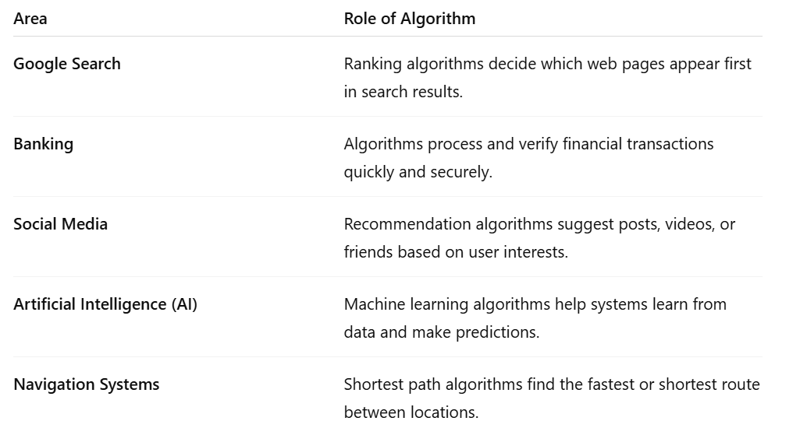
- Good algorithm + poor hardware = good performance
- Poor algorithm + powerful hardware = poor performance
How to Represent an Algorithm
Algorithms can be represented in different ways.
1. Natural Language
- Written in simple English.
- Easy for humans to understand.
- Not precise enough for programming because it can be ambiguous.
2. Pseudocode (Most Common)
- Looks like programming
- Easy to read
- Language independent

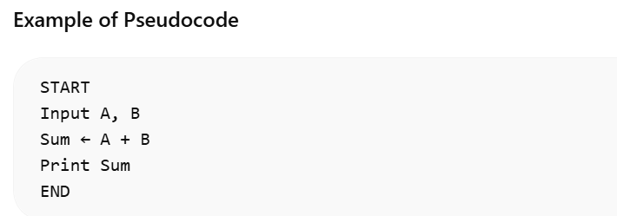
3. Flowchart
A graphical (visual) representation of an algorithm.
It uses different symbols to represent steps in the process.
Common Flowchart Symbols
- Oval: Start / End
- Parallelogram: Input / Output
- Rectangle: Process (calculation or action)
- Diamond: Decision (Yes/No or True/False condition)
4. Programming Language
- Written in C, Java, Python, etc.
- Used for implementation
Properties / Characteristics of Algorithms
A good algorithm must have the following properties:
1. Input
- An algorithm must have zero or more inputs.
- Input is the data given to the algorithm.
- Examples: numbers, strings, files.
2. Output
- An algorithm must produce at least one output.
- Output is the result after processing the input.
- Examples: sum of numbers, sorted list, decision result.
3. Precision
- The steps must be clear and unambiguous.
- Instructions should not create confusion.
- Example: Instead of saying “Process the data”, write “Add two numbers and store the result.”
4. Finiteness
- An algorithm must finish after a finite number of steps.
- It should not run forever.
- Example: A loop that runs forever violates this property.
5. Definiteness
- Each step must be precisely defined.
- The same input should always produce the same output.
6. Correctness
- The algorithm must give the correct result for all valid inputs.
- Example: A sorting algorithm should correctly sort any list.
7. Generality
- The algorithm should work for all valid inputs, not just one case.
- Example:
Works only for 5 numbers
Works for any number of inputs
Lecture 2
Fundamentals of Algorithmic Problem Solving
Introduction
Algorithmic problem-solving means solving a problem step-by-step using a clear and logical method called an algorithm.
Before writing any program, a programmer should:
- Understand the problem clearly
- Analyze what is required
- Plan a logical solution
This process helps improve:
- Accuracy
- Efficiency
- Code quality
Fundamentals of Algorithmic Problem Solving
Algorithmic problem solving includes:
- Clearly understanding the problem
- Identifying the input and output
- Designing logical steps to solve the problem
- Choosing suitable techniques
- Making sure the solution is correct and efficient
It is not about coding first — it is about thinking and planning the solution first.

The STAIR Steps for Solving Problems
The STAIR model is a step-by-step method used to solve problems in a systematic way.
S – Study the Problem
Understand the problem clearly and identify what is required.
T – Think of a Strategy
Decide the method or plan to solve the problem.
A – Act (Design the Algorithm)
Create logical steps (algorithm) to solve the problem.
I – Implement the Solution
Write the program based on the designed algorithm.
R – Review and Refine
Check the solution, find errors, and improve it if needed.
Step 1: Study the Problem
In this step, we understand the problem clearly before starting the solution.
Key Activities:
Read the problem carefully
Identify:
- Inputs
- Outputs
- Constraints
Understand what the problem is asking
Important Rule:
If the problem is not clear, the solution will likely be wrong.
Step 2: Think of a Strategy
In this step, we plan how to solve the problem.
Possible strategies:
- Brute force approach
- Divide and conquer
- Using loops or recursion
- Searching or sorting methods
- Mathematical logic
Choose a strategy that is:
- Simple
- Efficient
- Easy to implement
Step 3: Act (Design the Algorithm)
In this step, we convert the strategy into a clear step-by-step algorithm.
This includes:
- Writing pseudocode
- Drawing flowcharts
- Clearly defining each step
No programming syntax is required
The focus is on the logic of the solution
Step 4: Implement the Solution
In this step, the algorithm is turned into a working program.
This includes:
- Converting the algorithm into code
- Using a programming language (C, Java, Python, etc.)
Key Points:
- Follow the algorithm strictly
- Use proper variables
- Maintain readability of the code
Step 5: Review and Refine
After implementing the solution, we check and improve it.
This includes:
- Testing the program with different inputs
- Checking if the results are correct
- Finding and fixing errors
- Improving the solution if needed
This step ensures:
- Accuracy
- Efficiency
- Reliability
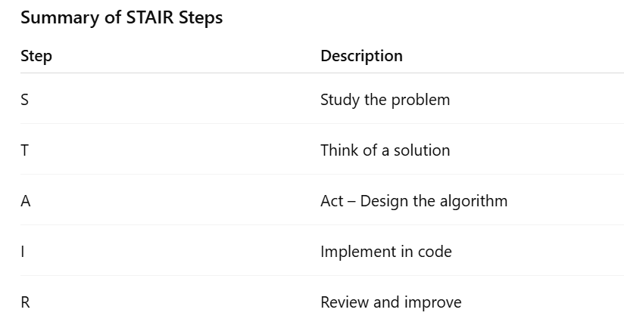
Major Factors in Designing an Algorithm
While designing an algorithm, the following factors should be considered:
- Correctness – The algorithm should produce the correct output for all valid inputs.
- Efficiency – The algorithm should use resources (time and memory) effectively.
- Simplicity – The steps should be easy to understand and follow.
- Time Complexity – The algorithm should take minimal time to run.
- Space Complexity – The algorithm should use minimal memory.
- Scalability – The algorithm should handle larger inputs without major performance issues.
- Maintainability – The algorithm should be easy to update or modify in the future.
Correctness
- Algorithm must produce correct output
- Works for all valid inputs
- Should handle edge cases
Most important factor
Efficiency
Efficiency refers to how well an algorithm uses resources.
It includes:
- Time taken to execute the algorithm
- Memory used during execution
Two types:
- Time Efficiency – How fast the algorithm runs
- Space Efficiency – How much memory the algorithm uses
An efficient algorithm saves resources.
Time Complexity
- Measures how the execution time of an algorithm grows as the input size increases
- Usually expressed using Big-O notation
Examples:
- O (1): Constant time (execution time does not change with input size)
- O (n): Linear time (time grows proportionally with input size)
- O (n²): Quadratic time (time grows with the square of input size)
Space Complexity
Memory required by algorithm
Includes:
- Variables
- Data structures
- Recursion stack
Less memory usage = better algorithm

Simplicity
- The algorithm should be easy to understand
- Avoid unnecessary complexity
- Clear logic makes maintenance easier
Simple algorithms are also easier to debug
Scalability
The algorithm should work efficiently for:
- Small inputs
- Large inputs
Must handle growth in data size without major performance issues
Maintainability
- The algorithm and code should be easy to modify or update
- Should be well-structured
- Include proper documentation
Important for long-term software projects
Example: Applying STAIR Steps
Problem: Find the maximum of two numbers
S – Study the Problem
- Inputs: Two numbers (e.g., 5 and 8)
- Output: The larger number
- Requirement: Find which number is greater
T – Think of a Strategy
- Compare the two numbers
- Decide which one is bigger
A – Act (Design the Algorithm)
- Start
- Read two numbers, A and B
- If A > B, then Maximum = A
- Else Maximum = B
- Print Maximum
- End
I – Implement the Solution
Write code in a programming language (e.g., Python, Java, C) using the above steps
R – Review and Refine
- Test with different inputs (e.g., 5 and 8, 10 and 3, -2 and -5)
- Check correctness and handle edge cases
Importance of Algorithmic Problem Solving
- Builds logical thinking
- Improves coding skills
- Reduces errors in programs
- Enhances performance of solutions
- Essential for job interviews and competitive programming
Conclusion
- Algorithmic problem solving is a structured approach to solving problems
- STAIR steps help in developing solutions systematically
- Good algorithm design leads to efficient and reliable programs
- Always focus on correctness, efficiency, and simplicity

Lecture 3
Iterative and Recursive Alogrithm
Iterative Algorithms
An iterative algorithm solves a problem by repeating a set of steps using loops (for, while, do-while) until a condition becomes false.
Key Characteristics
- Uses loops
- Has an explicit termination condition
- Uses less memory
- Easy to trace step-by-step
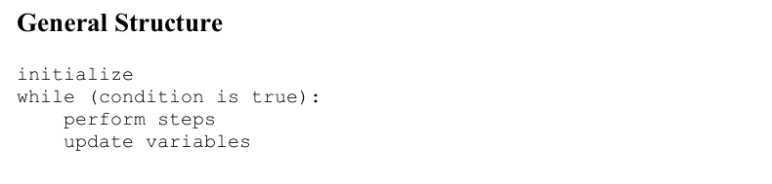
Recursive Algorithms
A recursive algorithm solves a problem by calling itself again and again with smaller parts of the problem until a stopping condition (base case) is reached.
Two Mandatory Parts
- Base Case – stops recursion
- Recursive Case – reduces the problem size
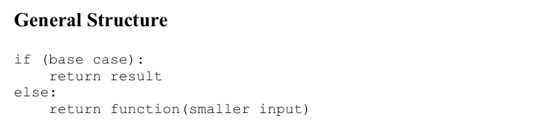
Examples
1. Fibonacci Series
(a) Iterative Fibonacci Algorithm Idea: Build the series step by step using a loop.
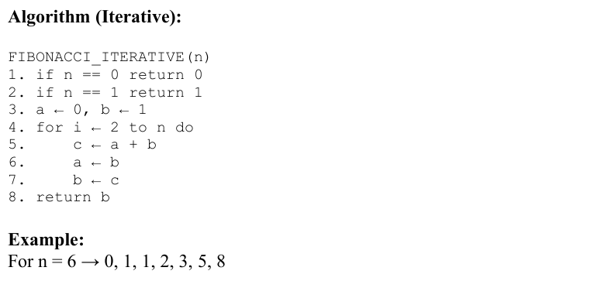
Code
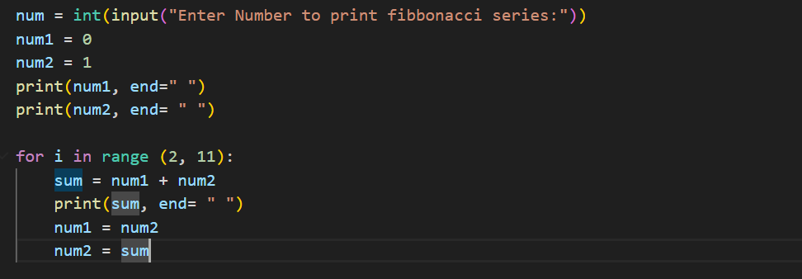
(b) Recursive Fibonacci Algorithm
Idea: Each Fibonacci number is the sum of the previous two
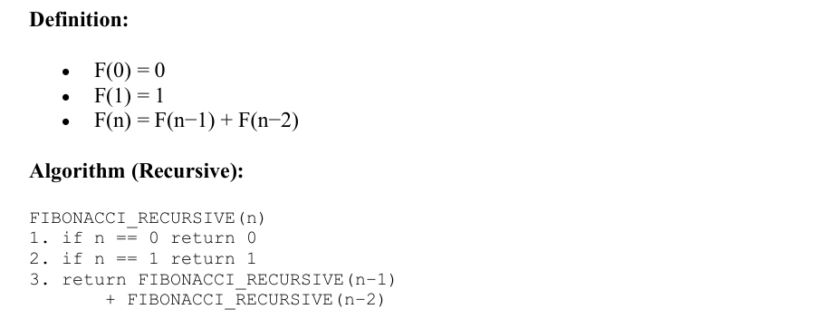
Code
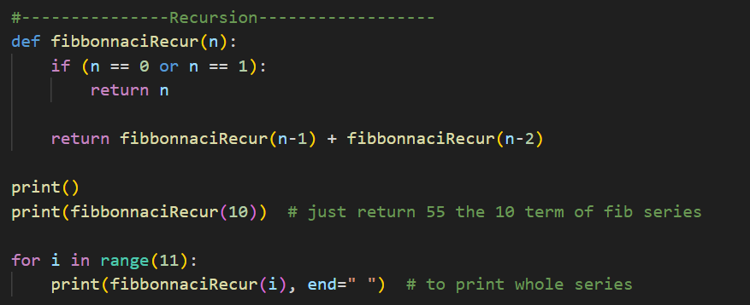

Visual Representation
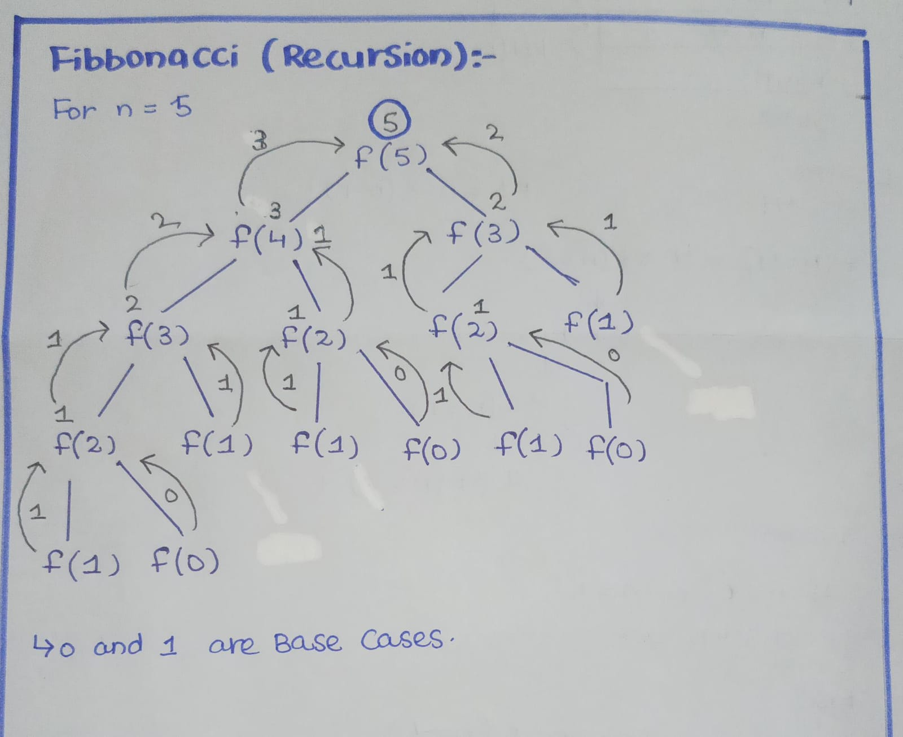
2. Factorial
(a) Iterative Factorial Algorithm
Idea: Multiply numbers from 1 to n using a loop.
Definition: n! = 1 × 2 × 3 × … × n
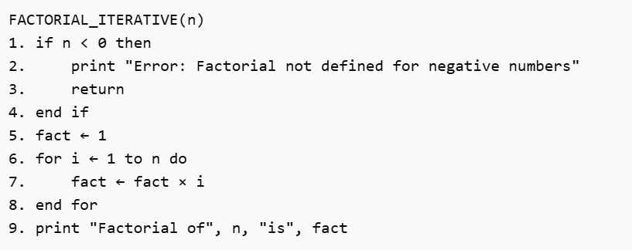
Code
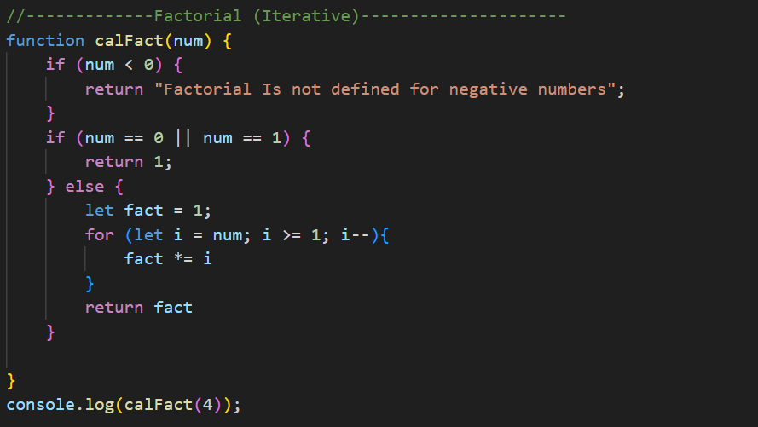
(b) Recursive Factorial Algorithm
Idea: Factorial defined in terms of smaller factorial.
Definition:
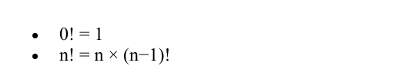
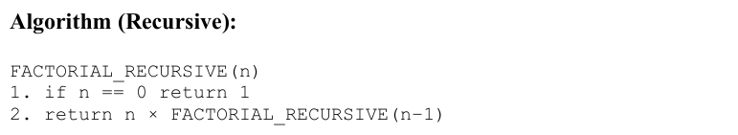

Code
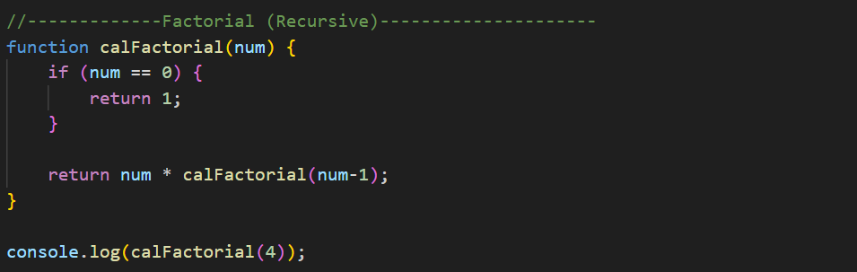
Visual Representation
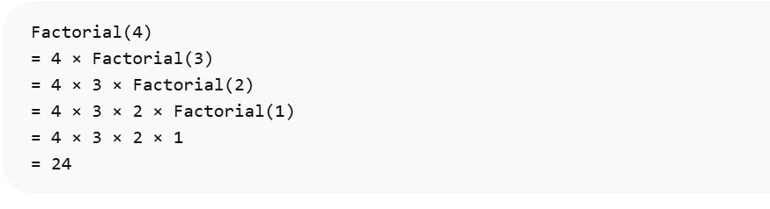
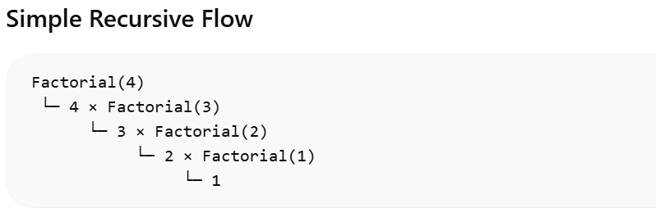

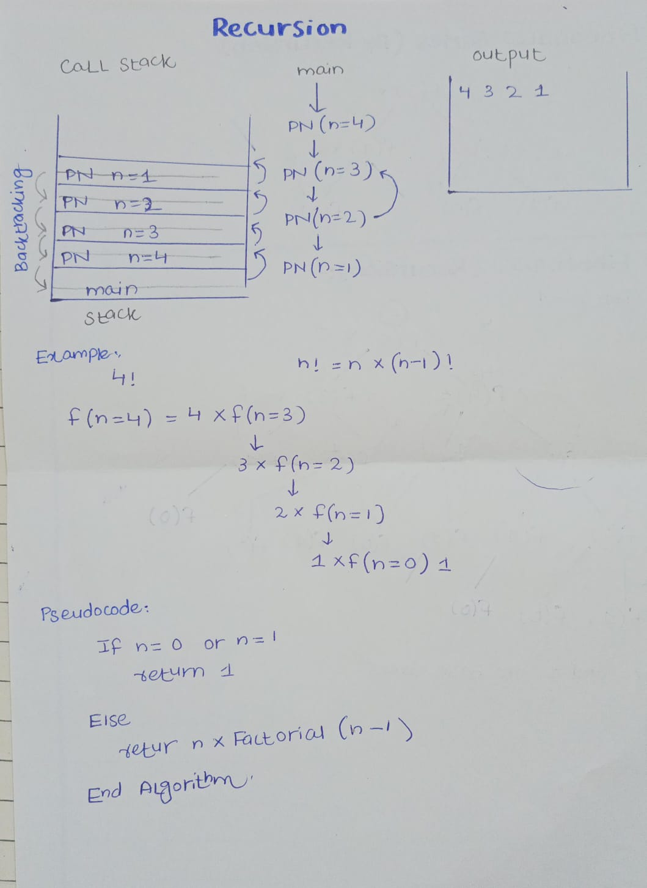
3. Binary Search Algorithm
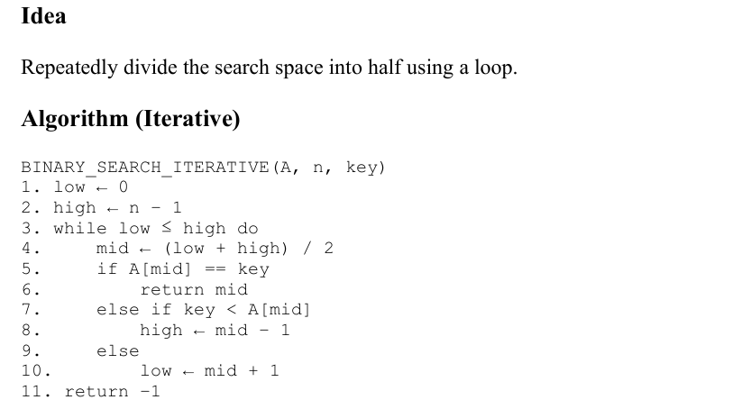
Code
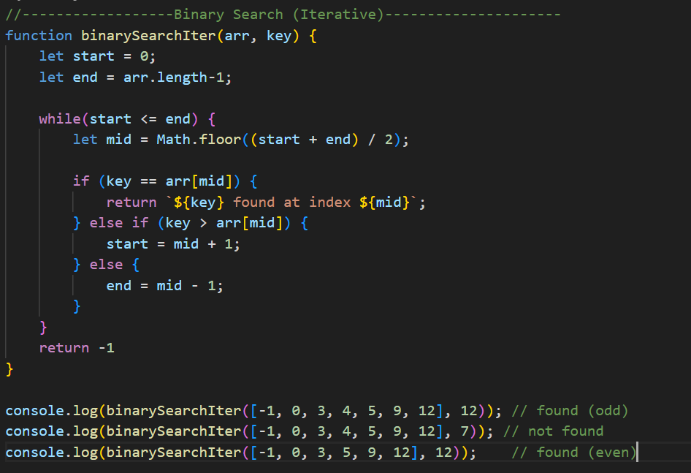
(b)- Recursive Binary Search Algorithm
Idea: Search the left or right half recursively.
Algorithm
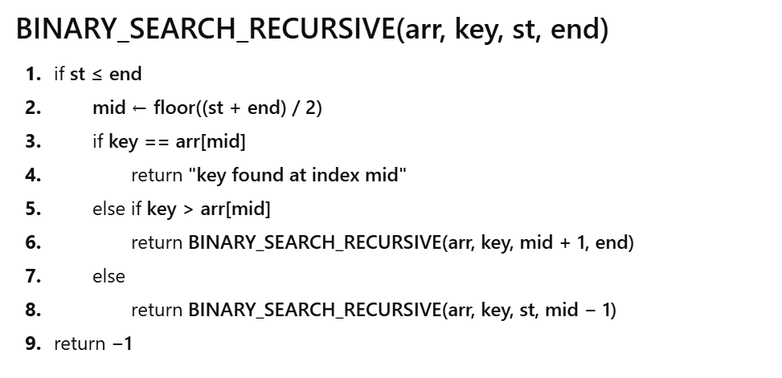
Code
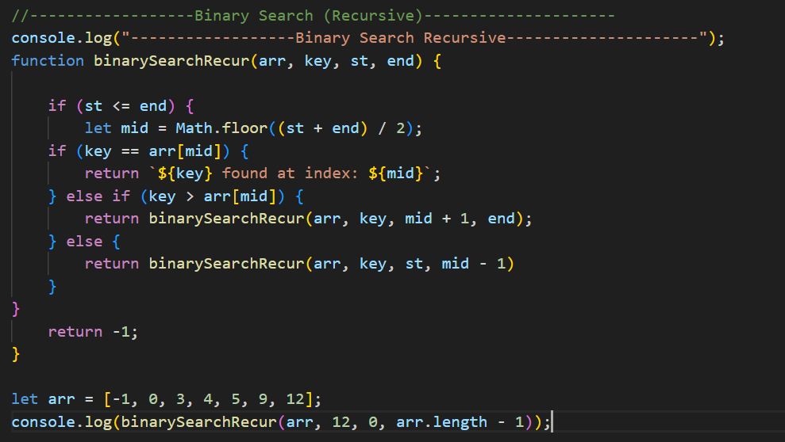
Lecture 4
Brute Force Strategy
Brute Force Strategy
Brute force is the simplest problem-solving method where we check all possible solutions and choose the correct or best one.
- It does not use smart techniques or shortcuts.
- Instead, it simply tries every possible option.
- It is usually easy to understand and implement, but it can become slow when the input size is large.
Key characteristics
- Simple and direct approach
- Checks every possible solution step-by-step
- Does not use optimization or preprocessing
- Always finds the correct answer because nothing is skipped
- Becomes inefficient when the input size is large
Example Algorithms Based on Brute Force
1. Bubble Sort
Idea
Repeatedly compare adjacent elements and swap them if they are in the wrong order. Larger elements “bubble up” to the end.
Algorithm (concept):
- Compare first two elements
- Swap if needed
- Move to next pair
- Repeat for all passes
Algorithm
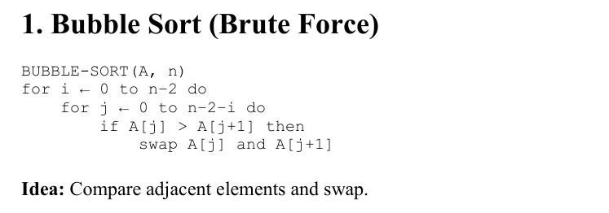
Code
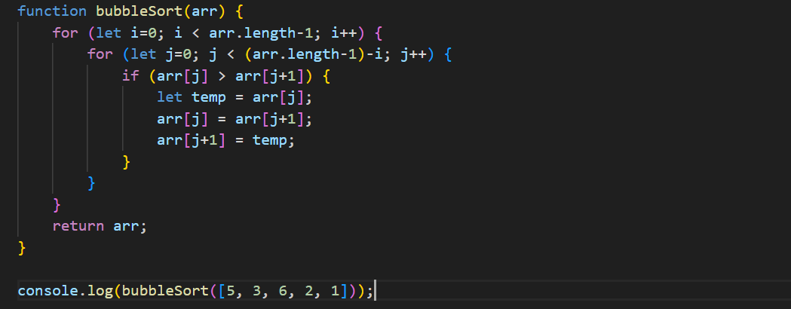
2. Selection Sort
Idea:
Repeatedly find the minimum element from the unsorted part and place it at the beginning.
Algorithm (concept):
- Find smallest element
- Swap with first position
- Move boundary of sorted part
- Repeat
Why brute force?
It always scans the entire unsorted portion to find the minimum.
Example:
- Array: [64, 25, 12, 22]
- First pass → minimum is 12, swap → [12, 25, 64, 22]
Algorithm
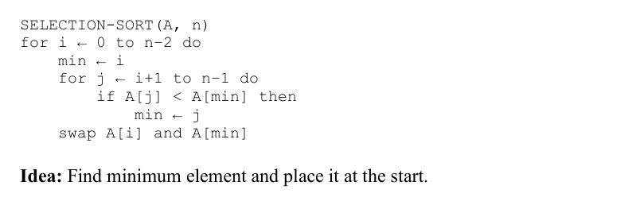Code
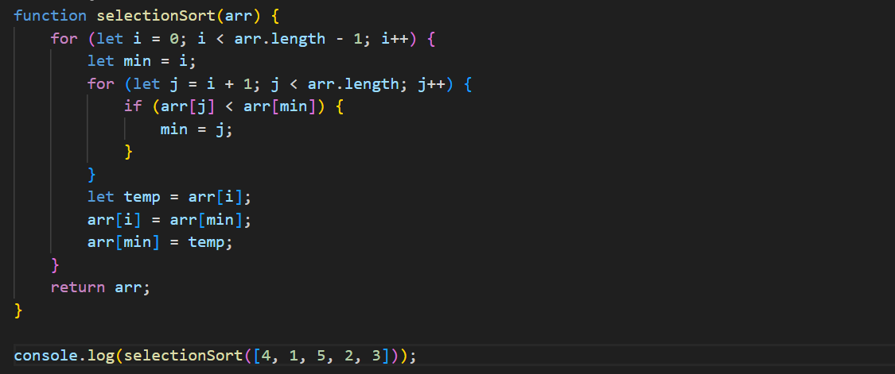

3. Insertion Sort
Idea: Build the sorted array one element at a time by inserting each element into its correct position.
Algorithm (concept):
- Start with second element
- Compare it with previous elements
- Shift larger elements right
- Insert at correct position
Why brute force?
Each new element is compared with all previous elements without skipping possibilities.
Example:
- Array: [8, 3, 5, 2]
- Sorted step-by-step → [2, 3, 5, 8]
Algorithm
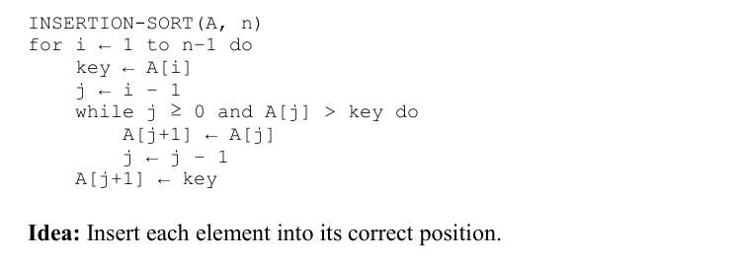

Code
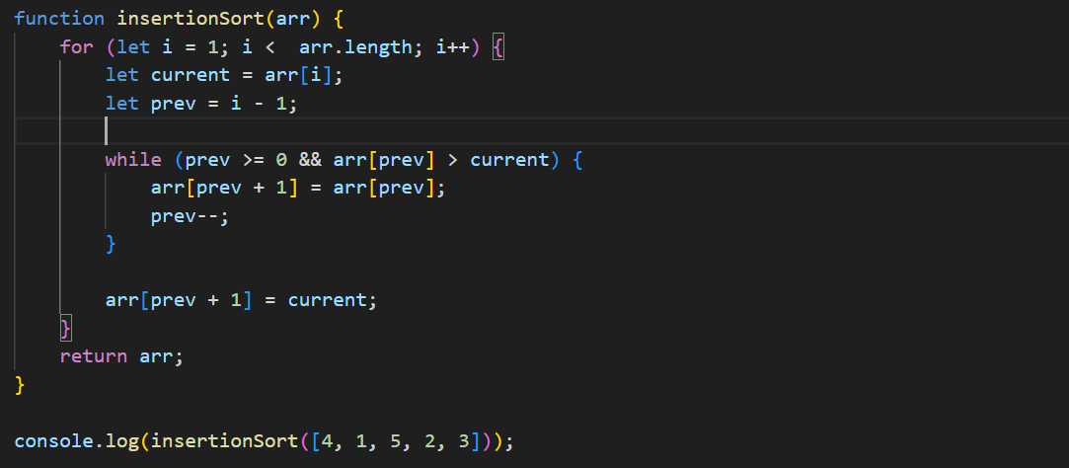
4. Brute Force Pattern Matching (String Matching)
Problem: Find a pattern P of length m in a text T of length n.
Idea: Try to match the pattern starting at every possible position in the text.
Algorithm (concept):
- Start from index 0 of text
- Compare pattern characters one by one
- If mismatch, shift pattern by one position
Repeat Why brute force?
- No preprocessing (like KMP); every shift is checked fully.
Example:
- Text: "ABABDABACDABABCABAB"
- Pattern: "ABABC"

Algorithm
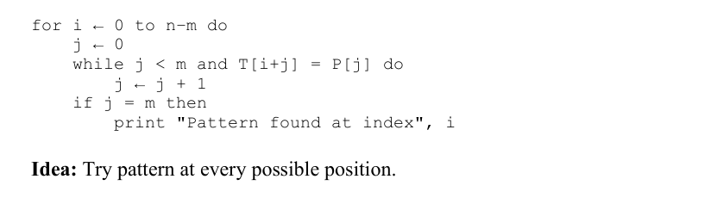
Code
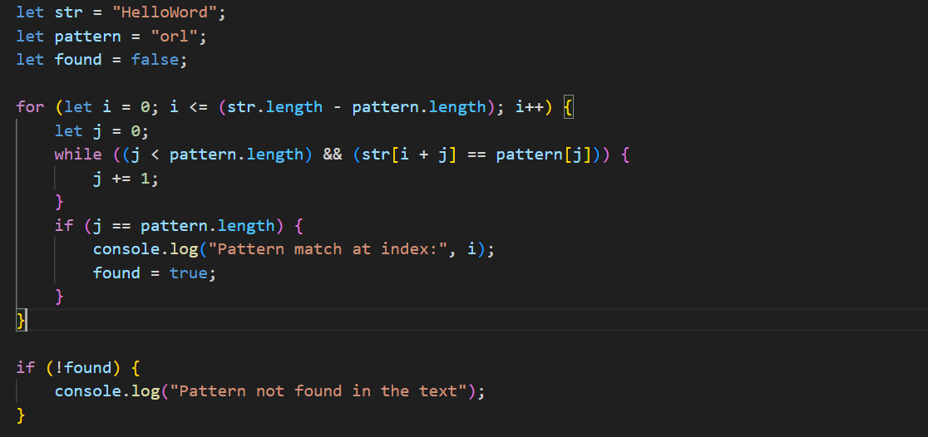

Dry run
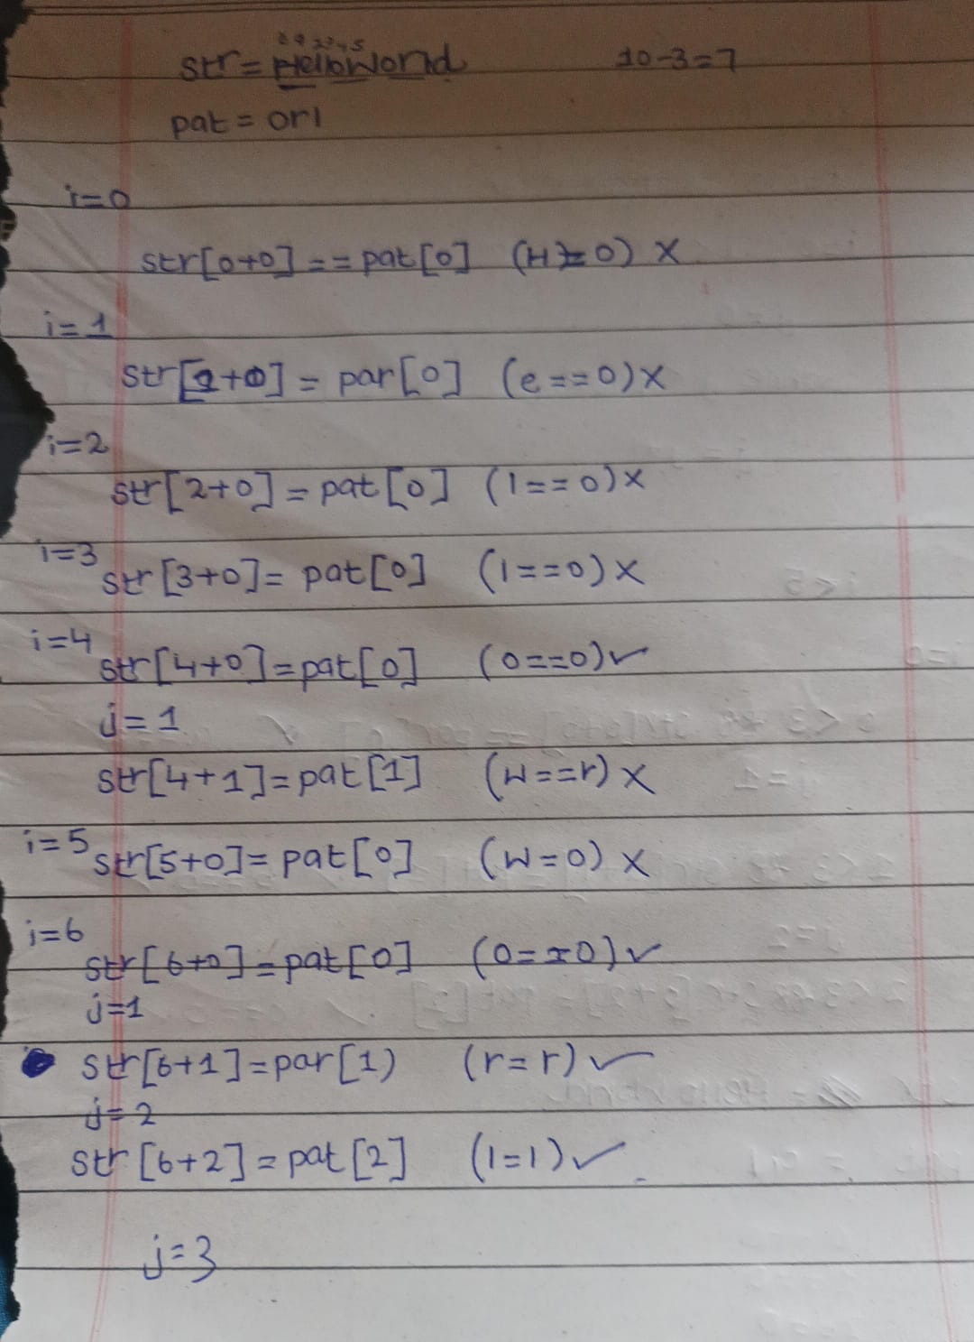
5. Closest Pair of Points (Brute Force)
Problem: Given n points in a plane, find the pair with the minimum distance.
Idea: Compute the distance between every possible pair of points. Algorithm (concept):
- For each point i
- Compare with every point j > i
- Keep track of minimum distance
Why brute force?
All combinations of pairs are checked without optimization.
Example: Points: (2,3), (12,30), (40,50), (5,1)
Check all pairwise distances → choose smallest
Algorithm
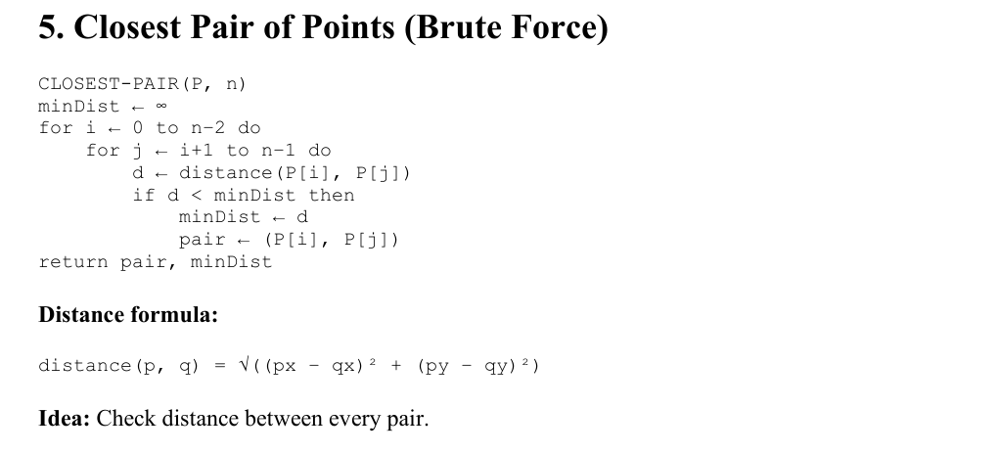

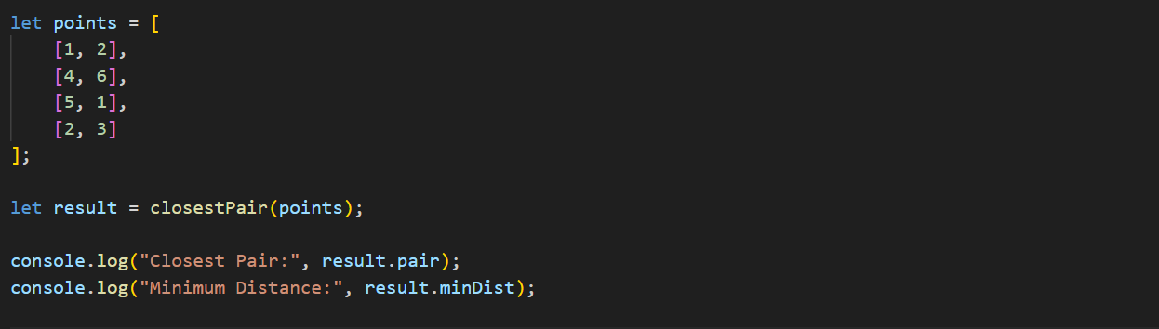
Code
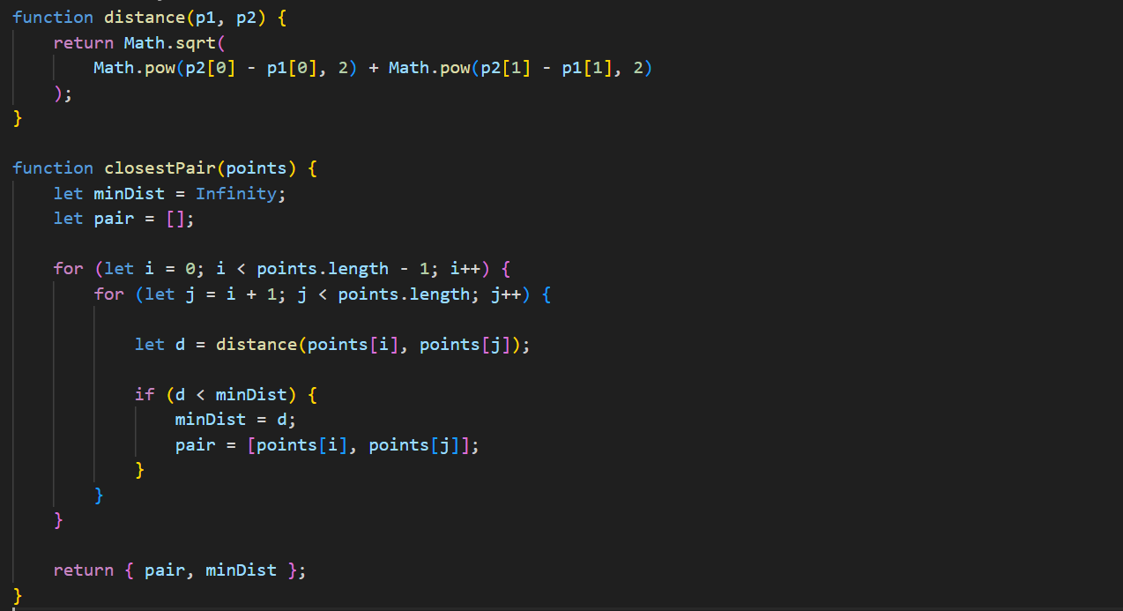
Lecture 5
Divide and Conquer Strategy
Divide and Conquer Strategy
Divide and Conquer is an algorithm design strategy in which a problem is solved by:
- Divide the problem into smaller subproblems
- Conquer the subproblems by solving them (usually recursively)
- Combine the solutions of subproblems to get the final solution
Subproblems are similar in nature to the original problem.
This strategy is much faster than brute force for large inputs.
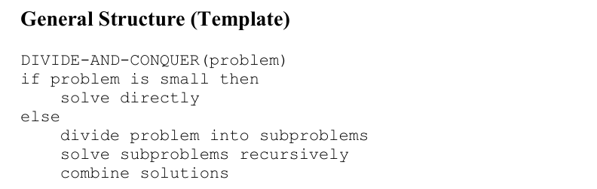
Example Algorithms Using Divide and Conquer
1. Merge Sort
Idea: Divide the array into halves, sort each half, then merge them.
Algorithm
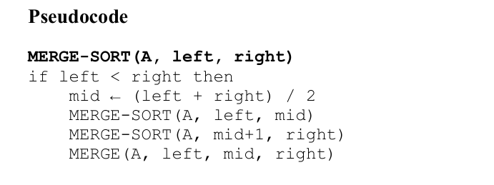
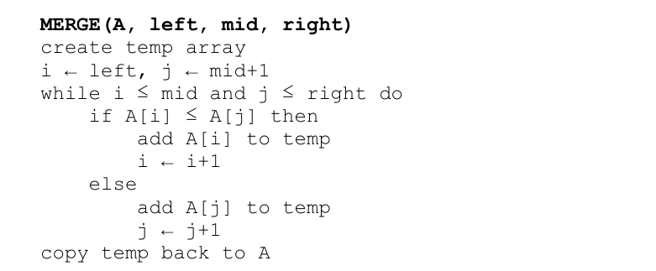

Code
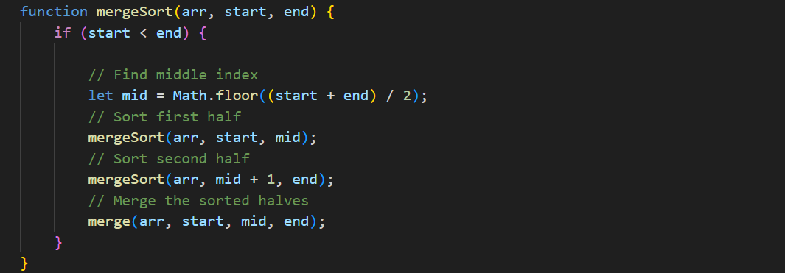
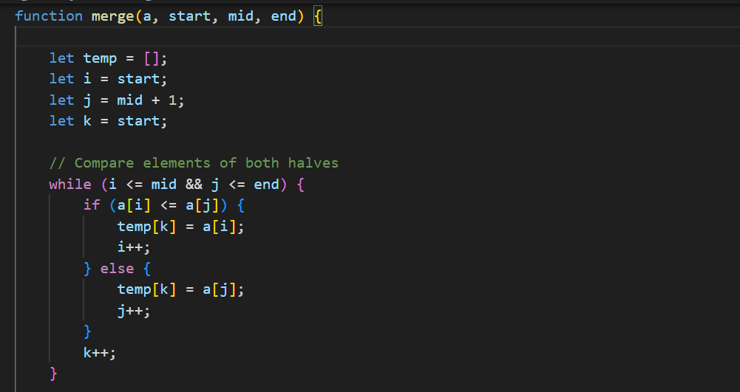

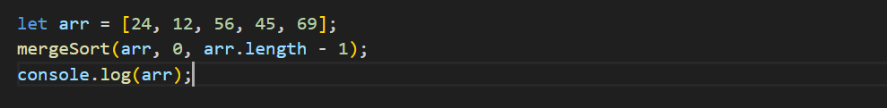
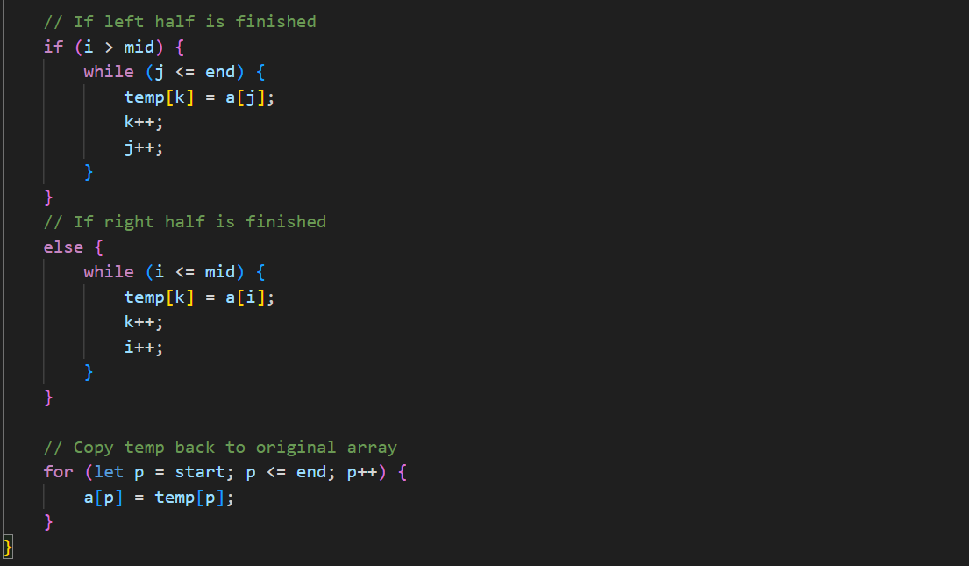
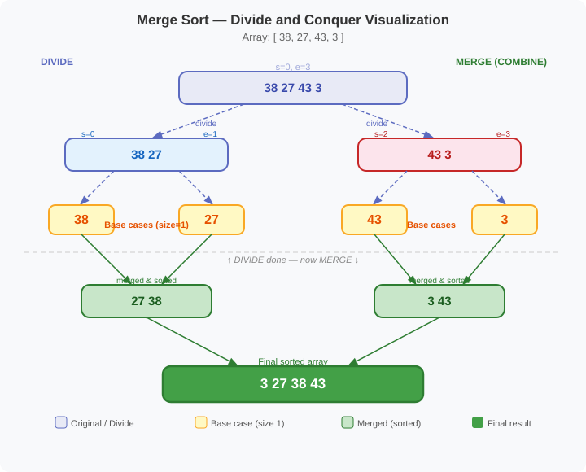
Visualization

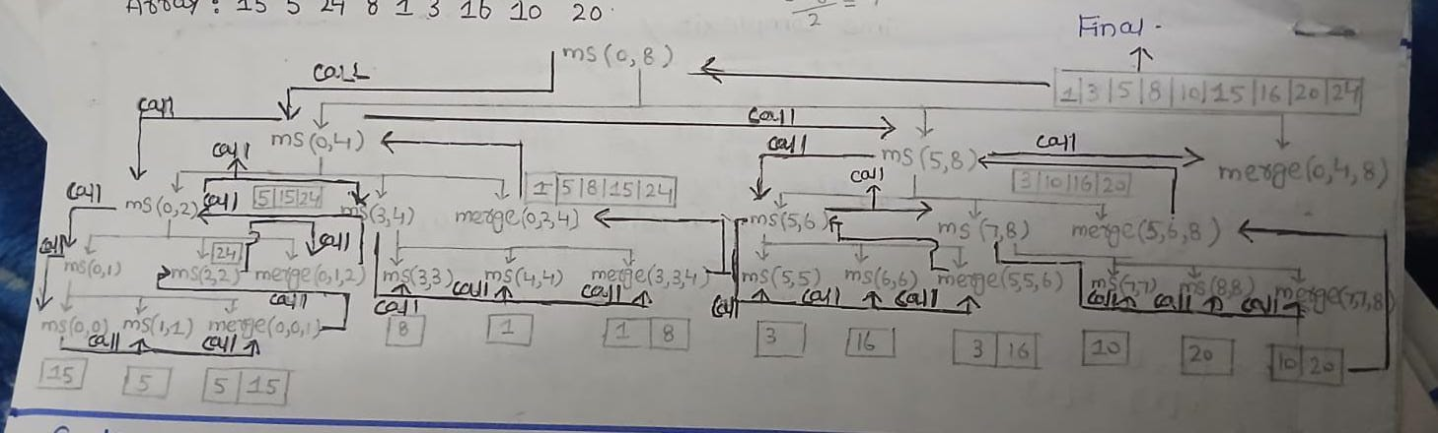
2. Quick Sort
Idea: Choose a pivot, place it in correct position, then sort left and right parts.
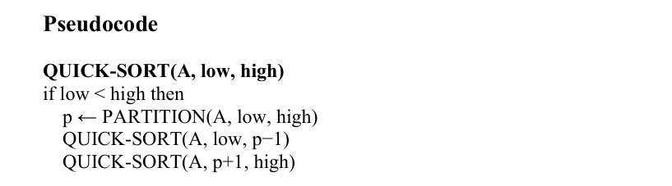
Algorithm

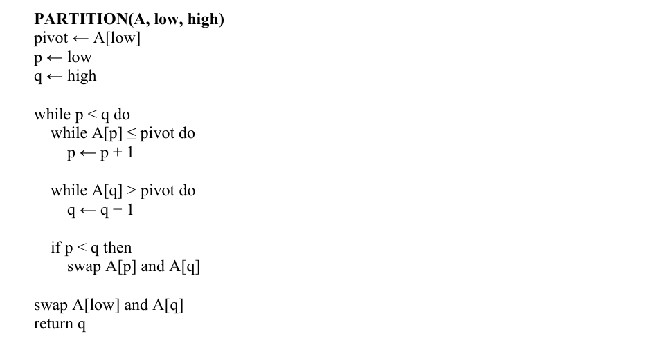

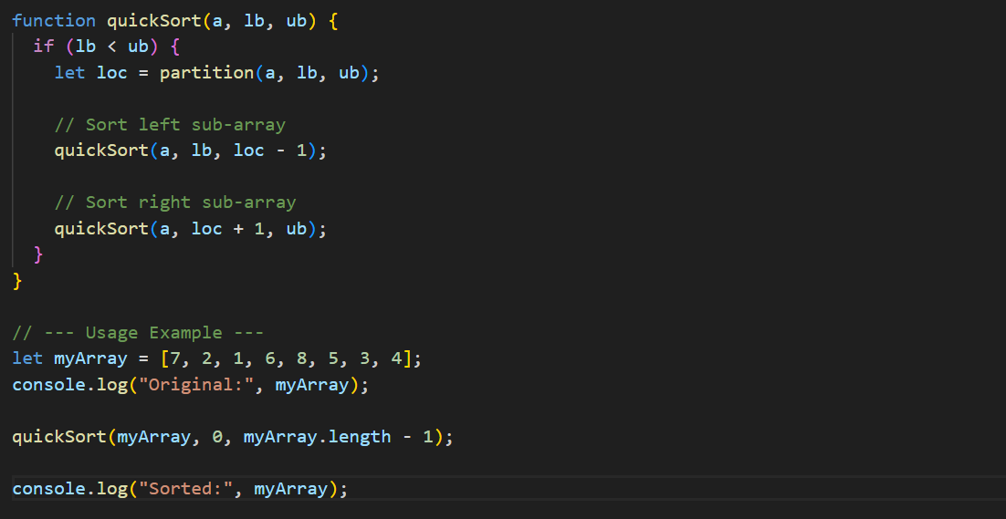
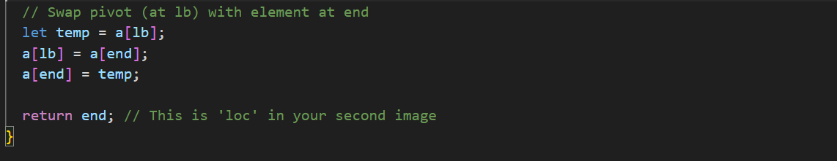
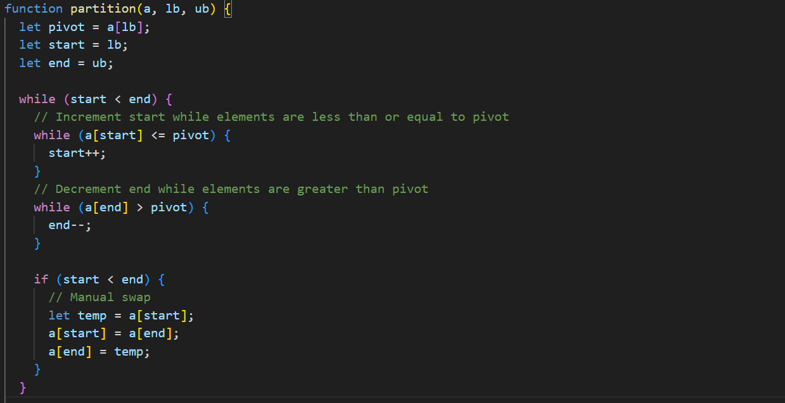
Code

Dry Run
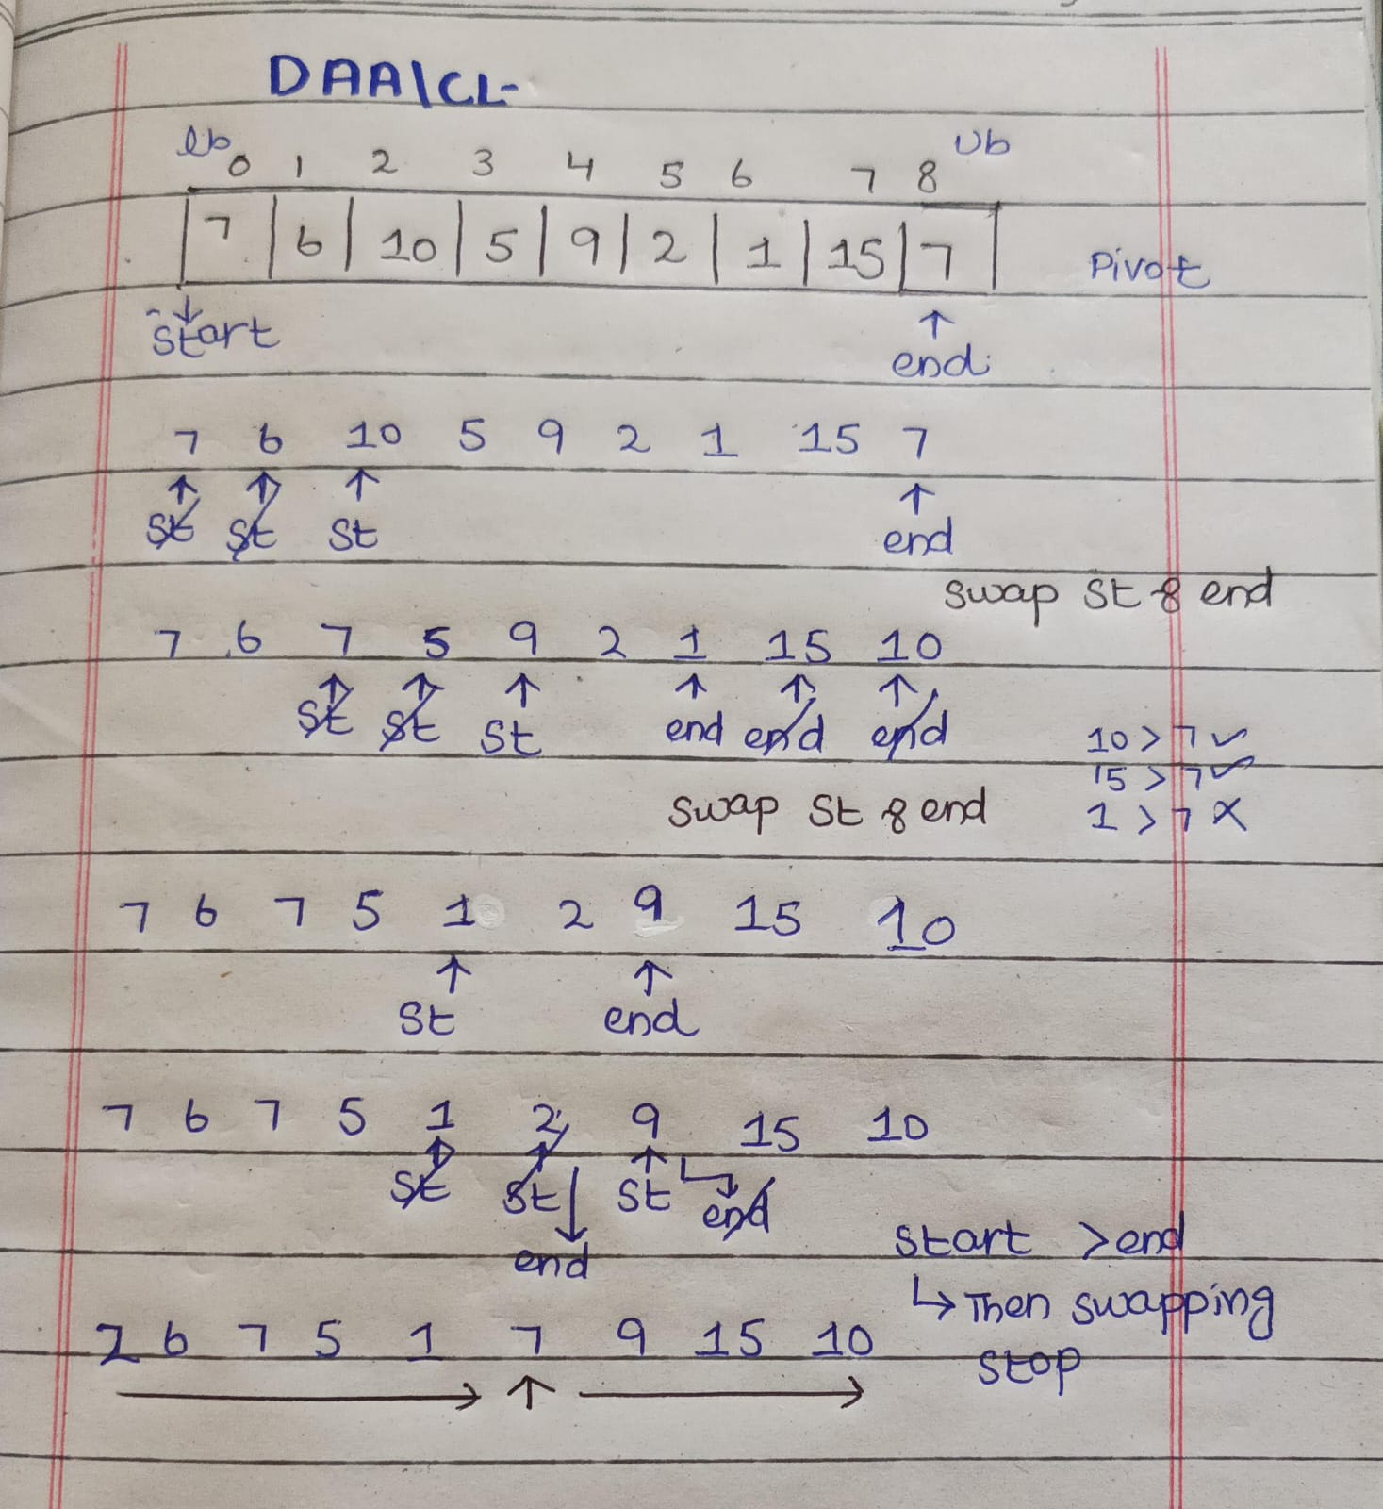

3. Binary Search (Divide and Conquer)
Idea: Search in a sorted array by repeatedly dividing the search space in half.
Binary Search only works on a sorted array.
Steps:
- Find the middle element of the array.
- Compare the target value with the middle element.
- If they are equal → element is found.
- If the target is smaller, search the left half.
- If the target is greater, search the right half.
- Repeat until the element is found or the range becomes empty.
Algorithm
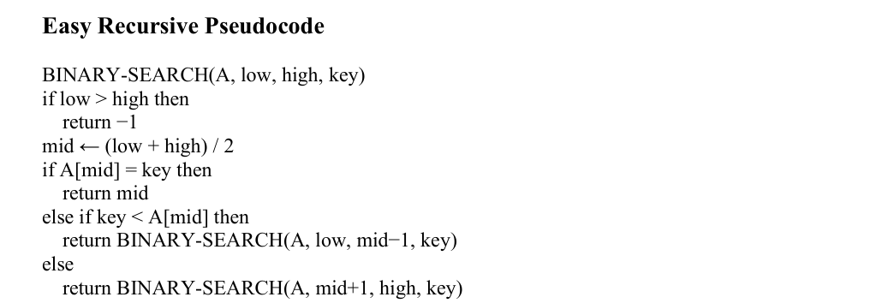

Code
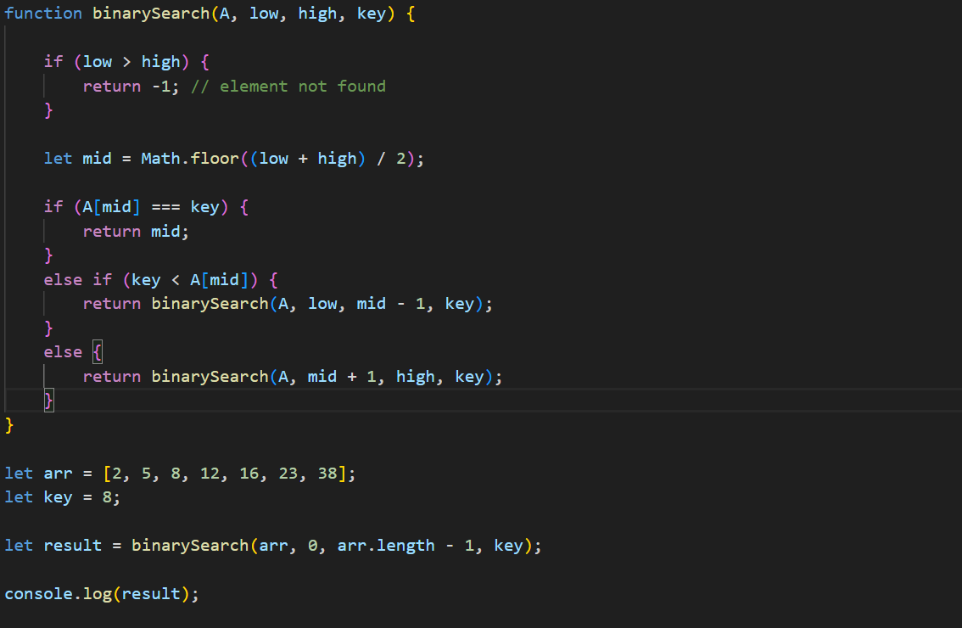Lecture 6
Greedy Strategy
What are Greedy Algorithms?
A greedy algorithm is an algorithmic strategy that:
- Makes the best local choice at each step
- Hopes that these local optimal choices lead to a global optimal solution
- Never reconsiders previous decisions (no backtracking)
In simple words:
Choose the best option available right now.

Greedy algorithms are usually:
- Simple
- Fast
- Efficient for optimization problems
But they do not always guarantee optimal solutions for every problem.
1. Knapsack Problem (Greedy Version)
There are two types:
- 0/1 Knapsack → Greedy does NOT always work
- Fractional Knapsack → Greedy works perfectly
1. Fractional Knapsack Problem
The Fractional Knapsack Problem is an optimization problem where we try to maximize the total value of items placed in a knapsack with limited capacity.
In this problem, items can be divided, meaning we can take a fraction of an item instead of taking the whole item.
Key Idea
You are given:
A set of items
Each item has:
- Weight
- Value
A knapsack with limited capacity
The goal is to select items (or fractions of items) so that the total value is maximum without exceeding the capacity.
Value per Weight Formula
To decide which item to take first, we calculate the value per unit weight.

Constraint
Σ xi · wi ≤ W: Weight of all objects included should be less than or equal to bag capacity.
Objective
max Σ xi · pi: Profit should be maximum.
Decision Variable (xᵢ)
- 0: not included
- 1: included
- between 0 & 1: partially included (0 ≤ xi ≤ 1)
Example
- n = no. of objects = 7
- W = capacity = 15

Table 1 — Objects with Profit, Weight and P/W Ratio
Objects | 1 | 2 | 3 | 4 | 5 | 6 | 7
Profit (P) | 5 | 10 | 15 | 7 | 8 | 9 | 4
Weight (W) | 1 | 3 | 5 | 4 | 1 | 3 | 2
P/W | 5 | 3.3 | 3 | 1.75 | 8 | 3 | 2

Table 2 — Greedy Selection (sorted by P/W)
Objects | Profit (P) | Weight (W) | Rem. Weight
5 | 8 | 1 | 15 - 1 = 14
1 | 5 | 1 | 14 - 1 = 13
2 | 10 | 3 | 13 - 3 = 10
3 | 15 | 5 | 10 - 5 = 5
6 | 9 | 3 | 5 - 3 = 2
7 | 4 | 2 | 2 - 2 = 0
 | 51 | 15

Algorithm
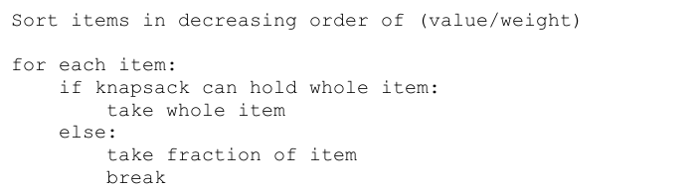
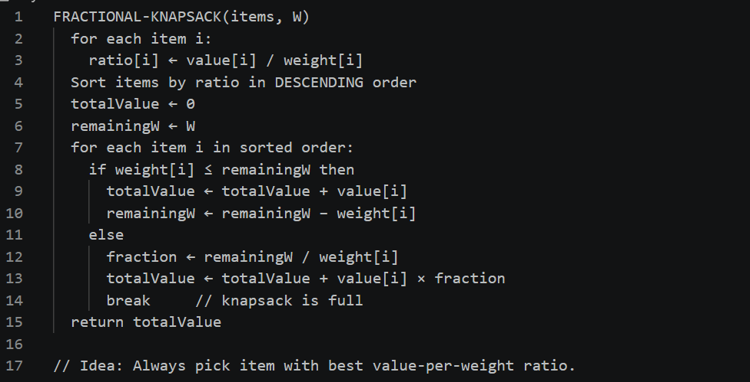
2. Huffman Coding (Greedy Algorithm for Compression)
David A. Huffman introduced Huffman Coding. It is a greedy algorithm used for data compression.
Idea
- Characters with higher frequency get shorter codes
- Characters with lower frequency get longer codes
- Minimizes total number of bits
Greedy Steps
- Pick two smallest frequencies
- Combine them
- Insert back into list
- Repeat until one tree remains.

Algorithm
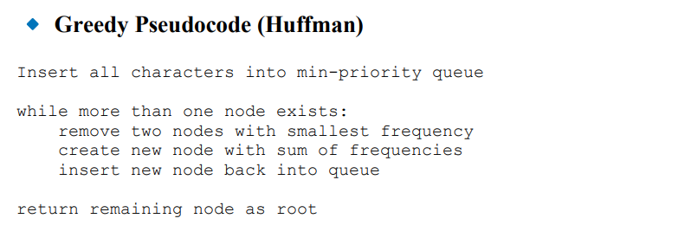
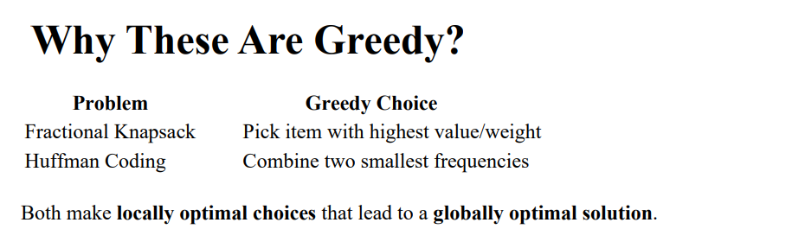

Example
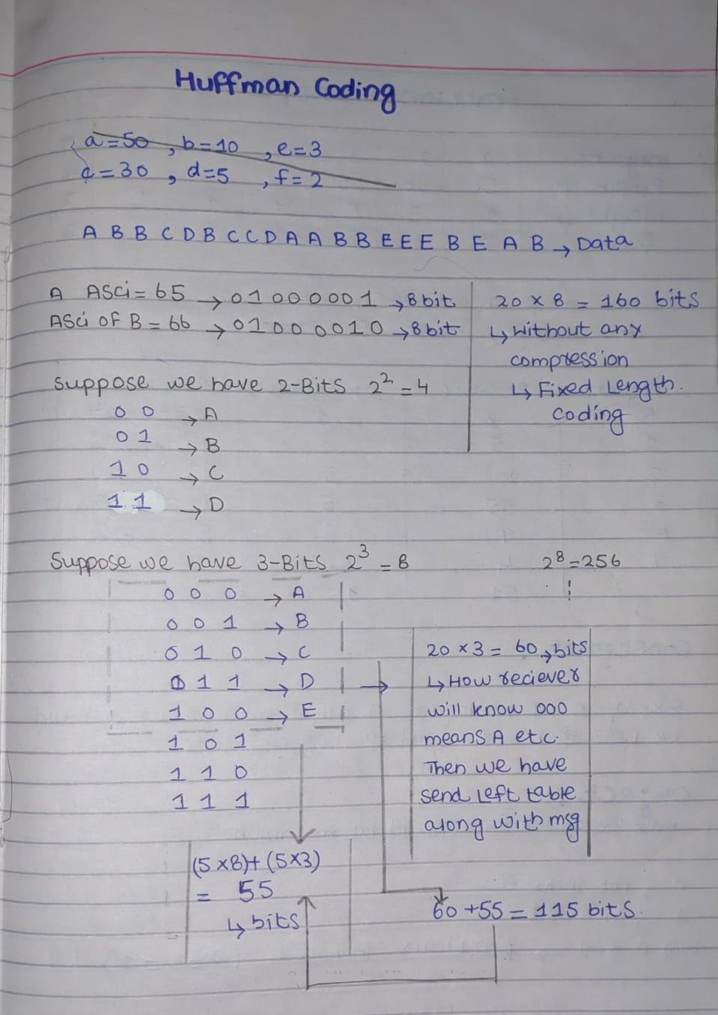
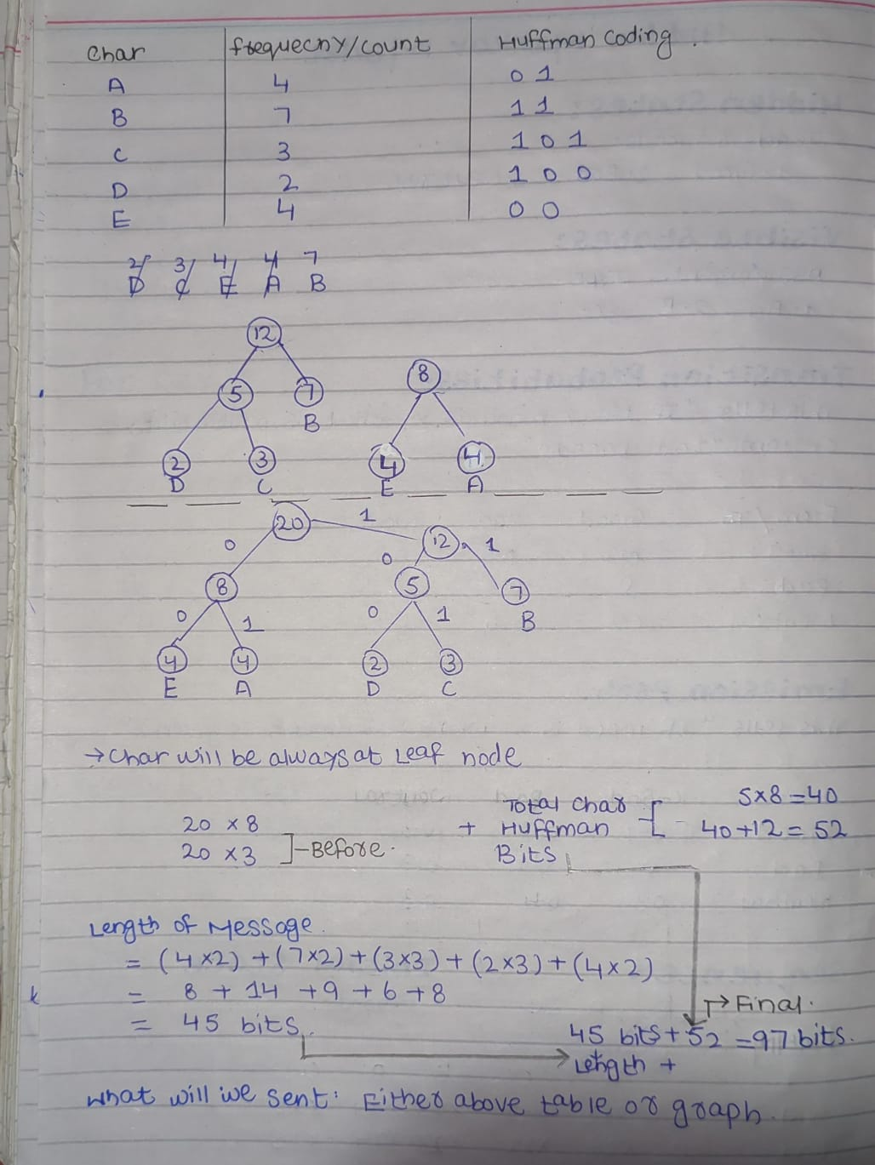
Example 2
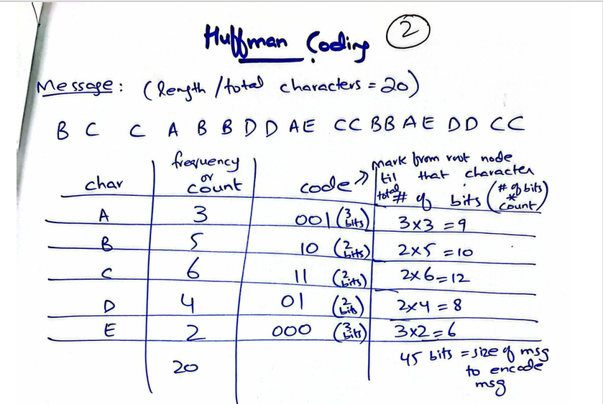
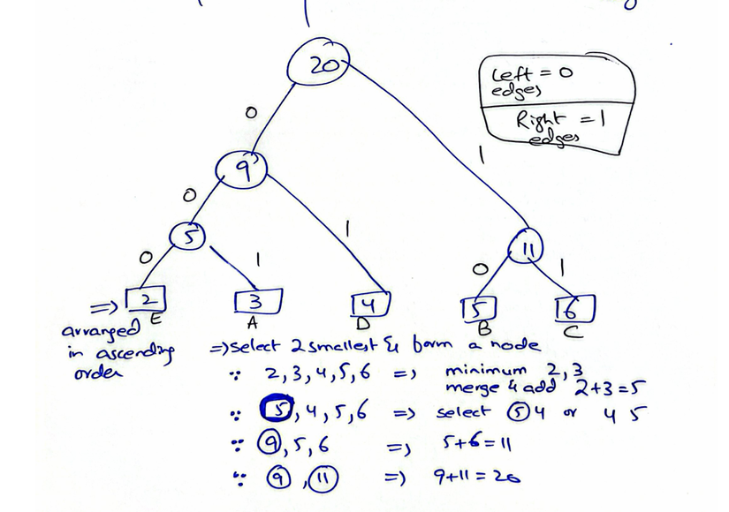
Lecture 7
Dynamic Programming
What is Dynamic Programming?
Dynamic Programming is a problem-solving technique where we break a big problem into smaller parts, solve them once, and store their answers so we don’t repeat the same work again.
When do we use DP?
We use DP when:
1. Optimal Substructure
The best solution of a big problem comes from the best solutions of its smaller parts.
Simple idea: Solve small → combine → get best final answer
2. Overlapping Subproblems
- Same small problems are solved again and again.
- DP avoids this repetition by saving results
How DP avoids repeated work?
1. Memoization (Top-Down)
- Solve problem using recursion
- Store results when you compute them
- Next time, just reuse stored value
- Like: “Already solved? Don’t solve again.”

2. Tabulation (Bottom-Up)
- Start solving from smallest problems
- Build up step by step to the final answer
- Like: “Start from base → go upward”
Simple Idea in One Line
DP = Break problem + Store answers + Reuse them
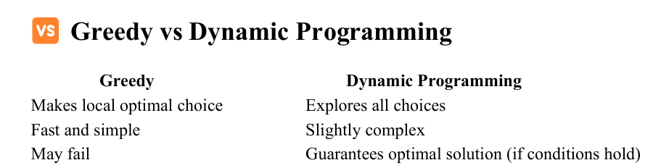

1. Longest Common Subsequence (LCS)
The Longest Common Subsequence problem finds the longest sequence that appears in both strings in the same order (not necessarily contiguous).
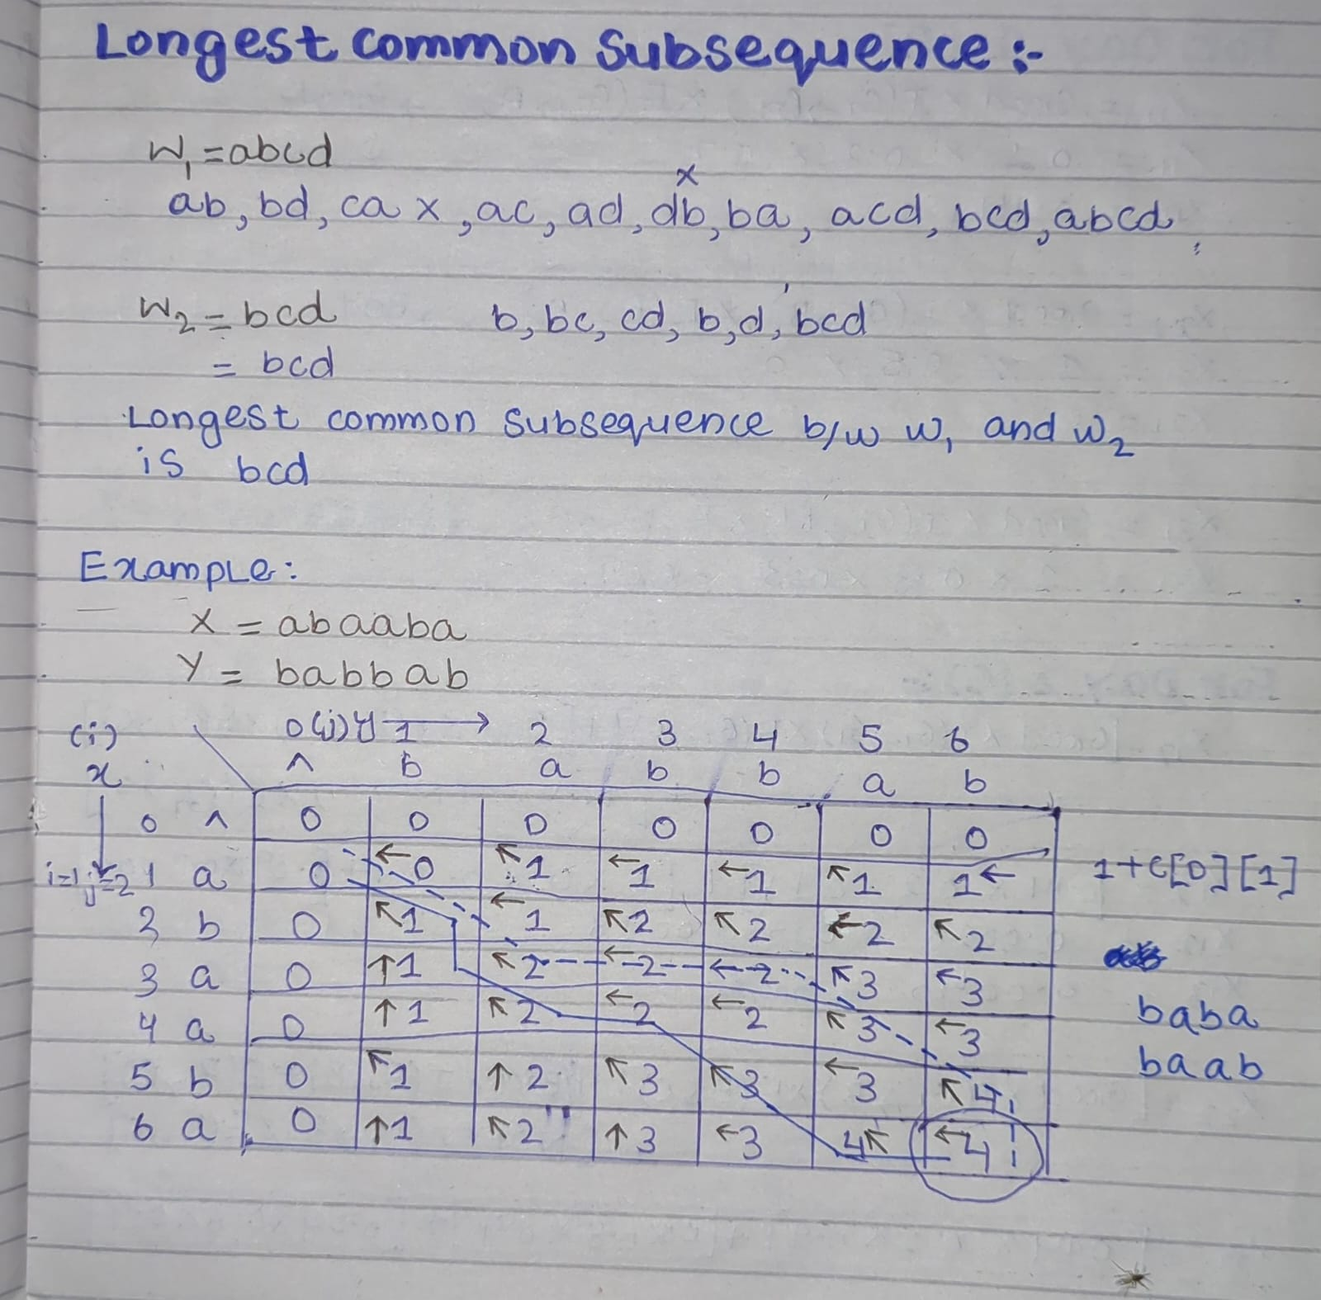

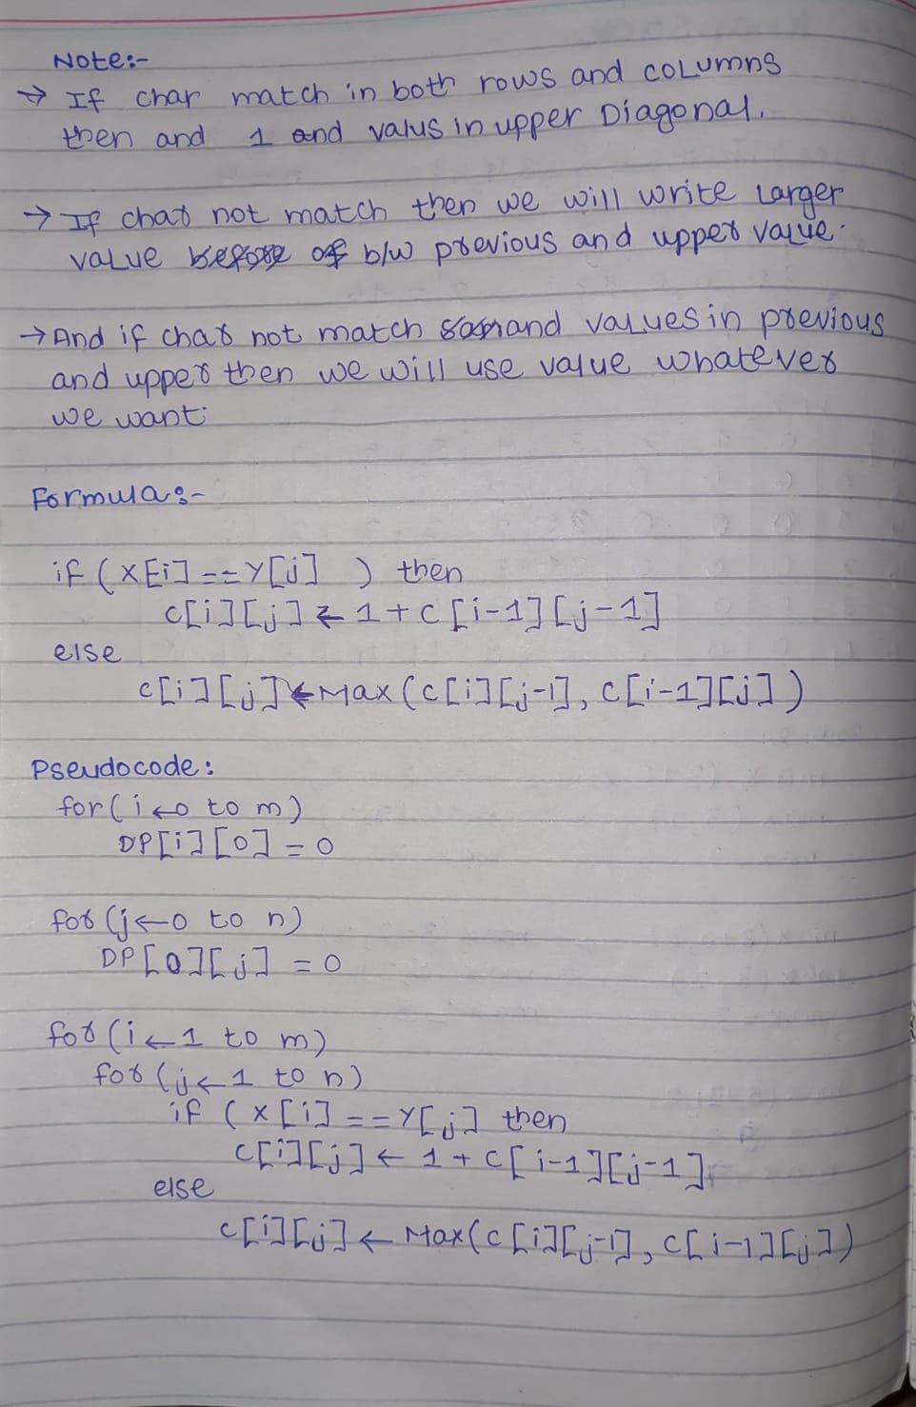
0/1 Knapsack (Dynamic Programming)
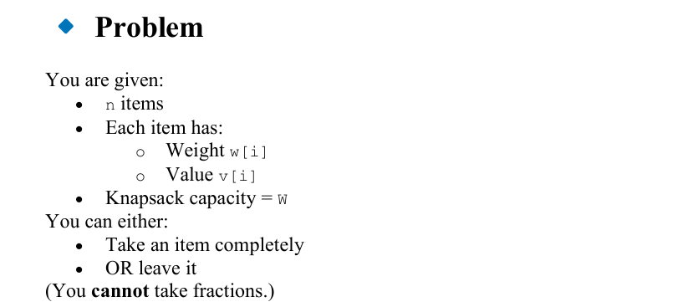
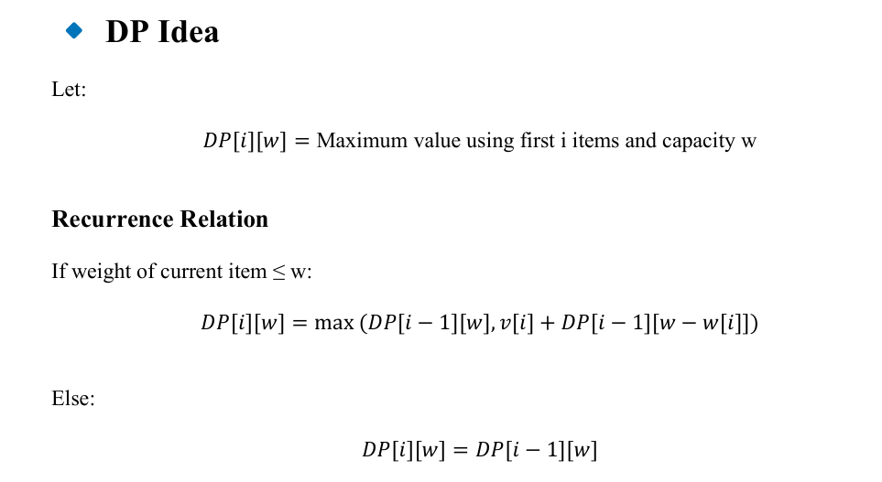
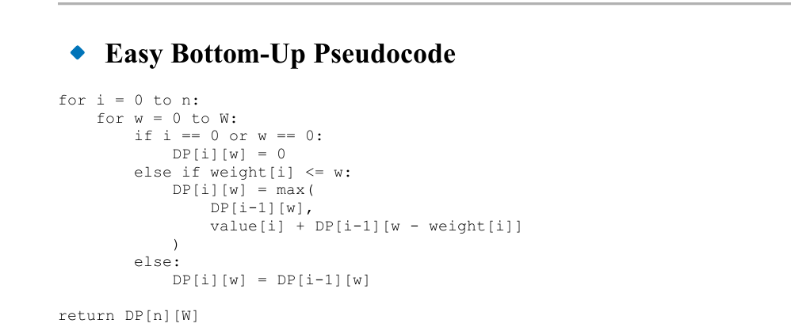
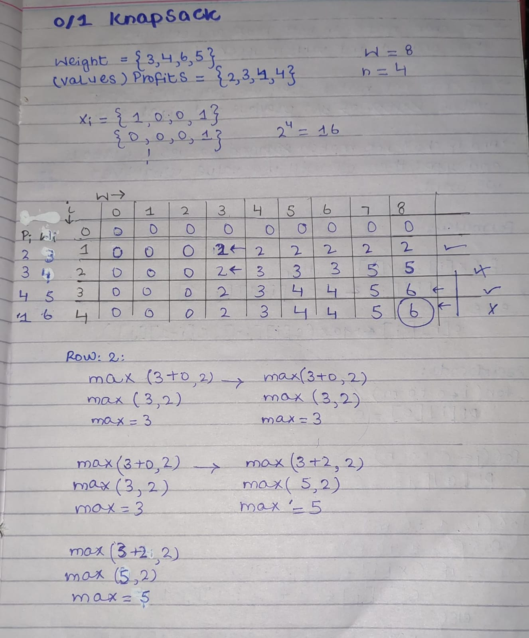

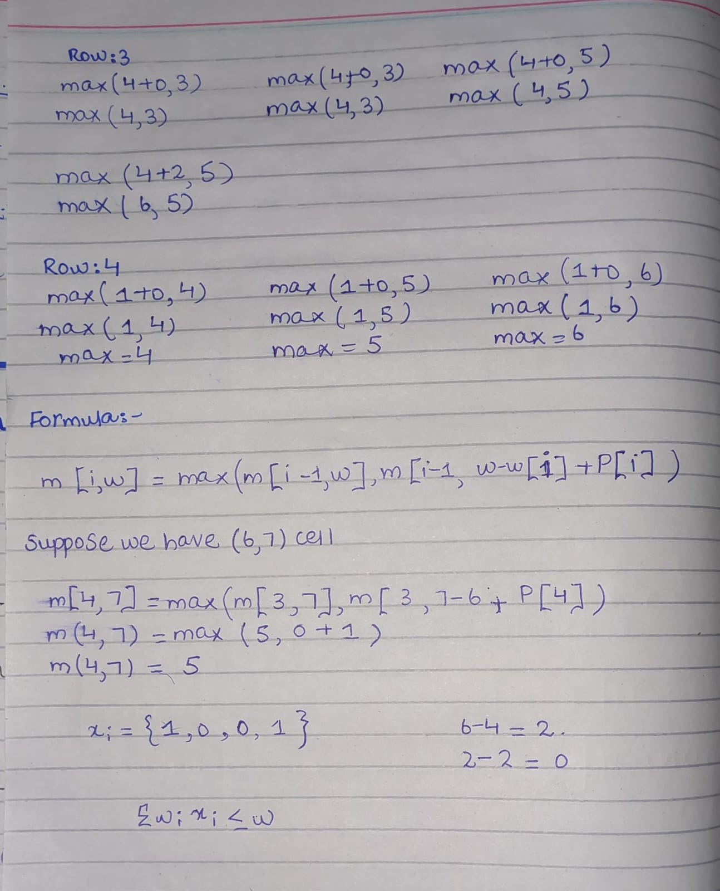

Lecture 9
Asymptotic Notations
Asymptotic Notations
In Analysis of Algorithms, asymptotic notations are mathematical tools used to describe the growth rate of an algorithm’s running time or space requirement as the input size 𝑛 becomes very large. Instead of focusing on exact execution time (which depends on machine speed, compiler, hardware, etc.), we study how the algorithm behaves for large inputs.
They help us answer:
“How efficient is this algorithm as input size increases?”
Why Do We Need Asymptotic Notations?
Suppose two students write programs for sorting:
Program A
T(n) = 5n + 10
Program B
T(n) = 0.01n² + 2
For small 𝑛, Program B may seem faster. But for very large 𝑛, Program A becomes much better.
So instead of exact values, we study the rate of growth. That is the purpose of asymptotic analysis
Main Asymptotic Notations
There are three major notations:
- Big-O Notation → O
- Big-Omega Notation → Ω
- Big-Theta Notation → Θ
Sometimes also:
4. little-o
5. little-omega
But the first three are most important.
1. Big-O Notation (O) — Upper Bound
Definition
Big-O tells us the maximum time an algorithm can take.
In simple words:
“The algorithm will not take more than this time.”
What does it mean?
- It shows the worst-case scenario
- It tells us the upper limit of time
- Even if things go badly, the time will stay within this bound
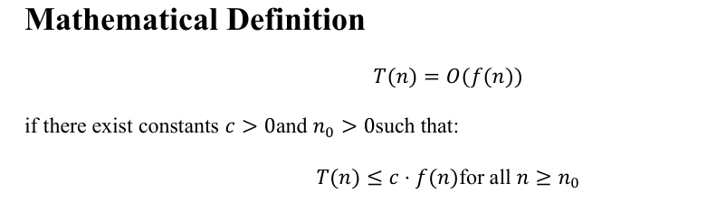
Simple Meaning
After some point, the running time never grows faster than 𝑓(𝑛).

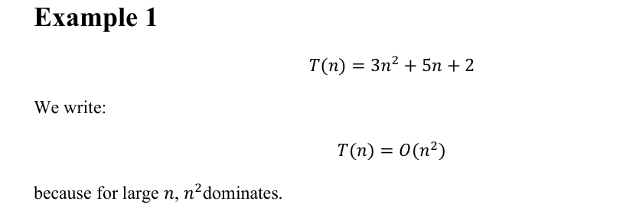
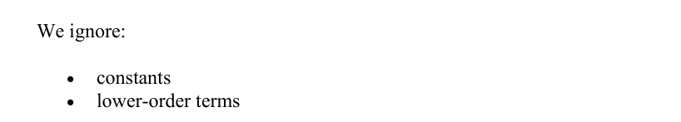
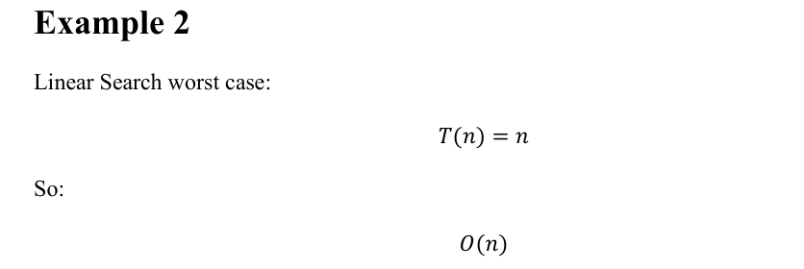
2. Big-Omega Notation (Ω) — Lower Bound
Definition
Big-Omega tells us the minimum time an algorithm will take.
In simple words:
“The algorithm will take at least this much time.”

What does it mean?
- It shows the best-case scenario
- It gives the lower limit
- The algorithm cannot be faster than this
Example
If an algorithm is:
Ω(n)
It means:
- It will take at least n time
- It may take more (like n²), but never less than n
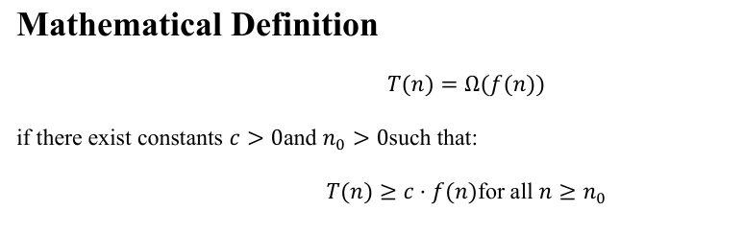
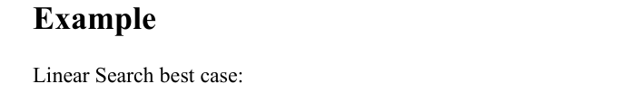
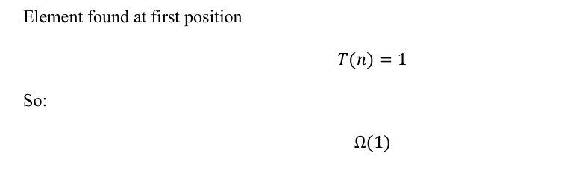
3. Big-Theta Notation (Θ) — Tight Bound
Definition
Big-Theta tells us the exact growth rate of an algorithm.
In simple words:
“The algorithm grows exactly like this.”
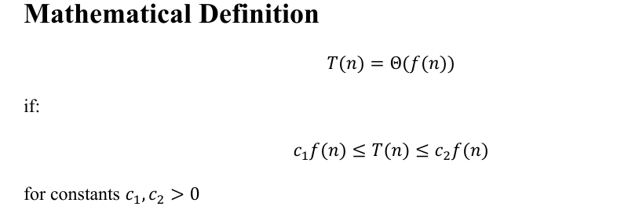
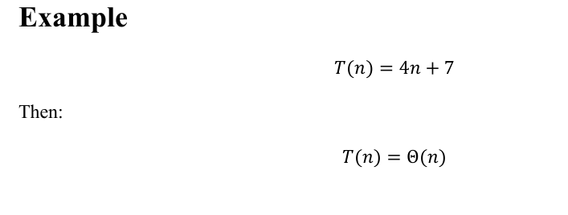
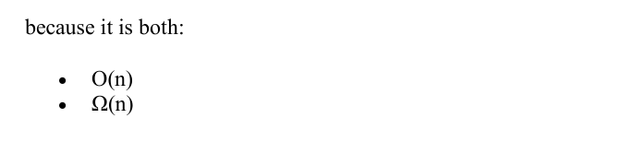

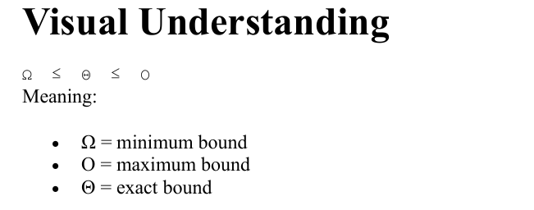
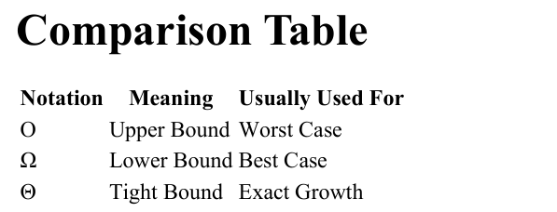
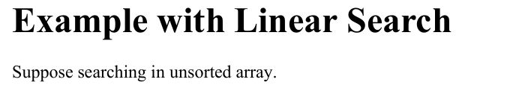
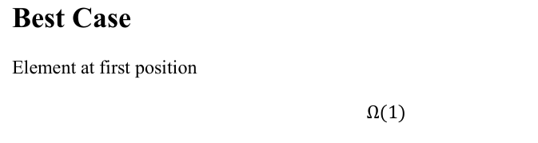

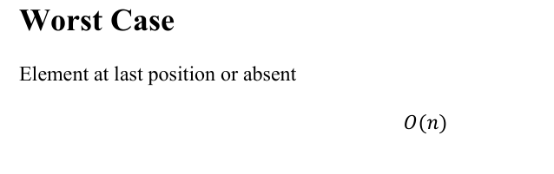
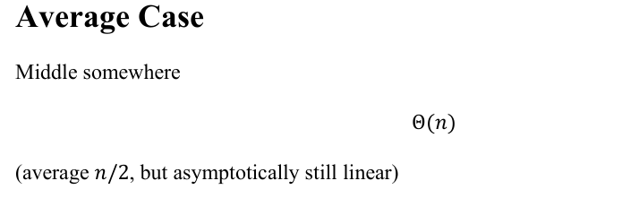
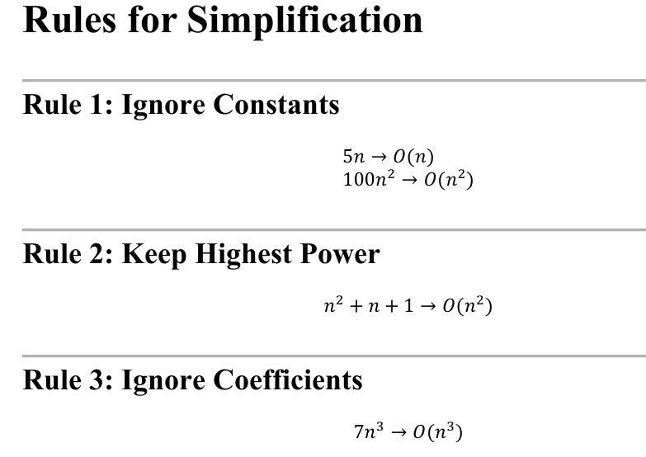
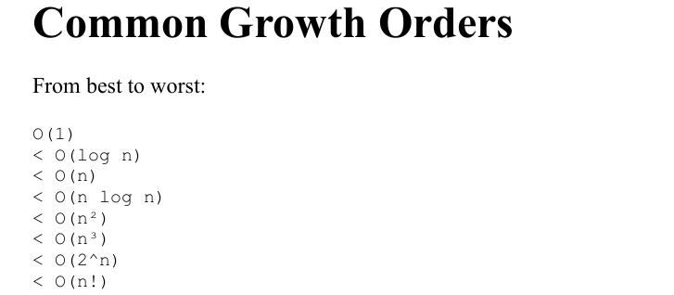
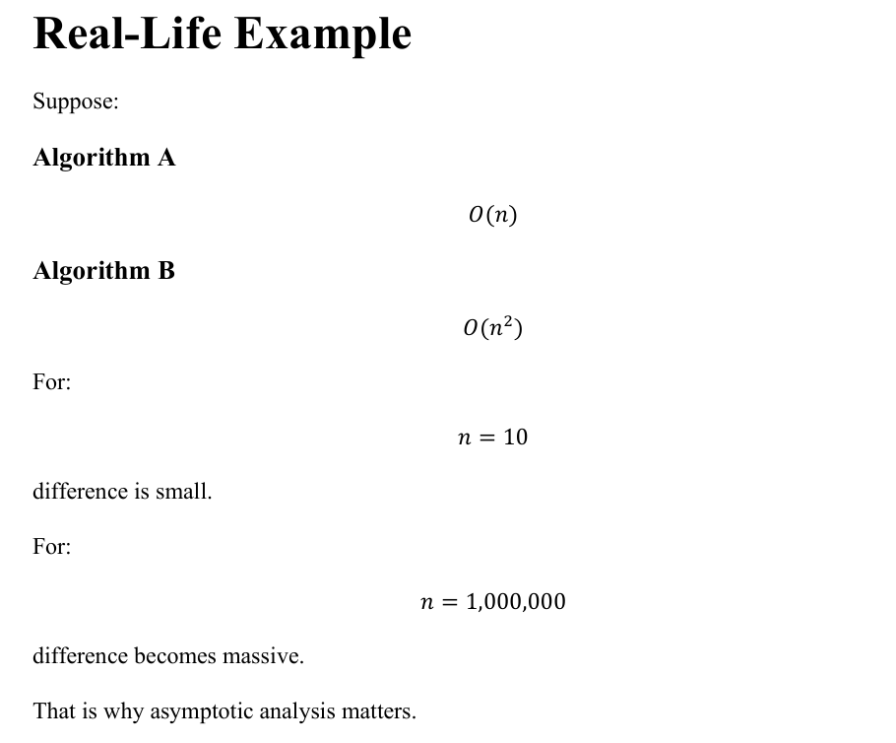

Lecture 10
Complexity Classes
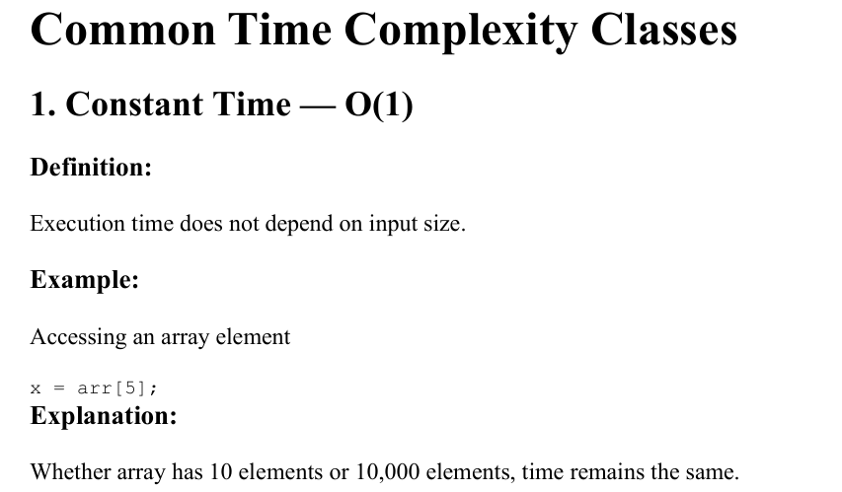
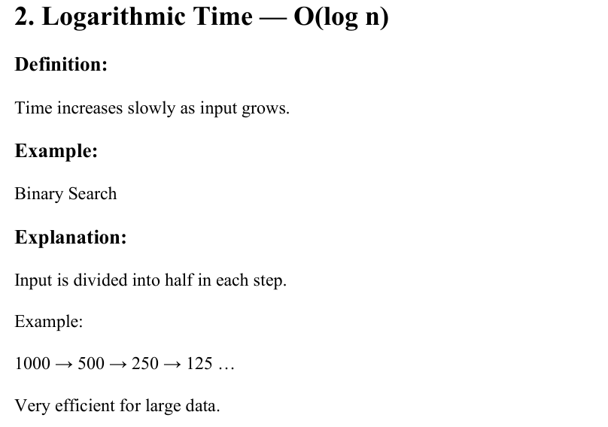
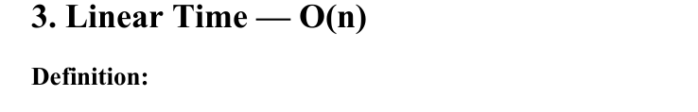
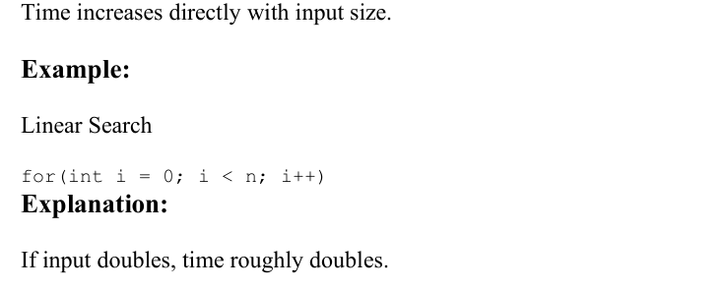
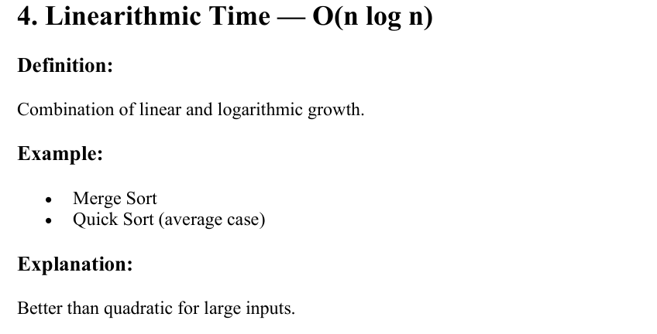

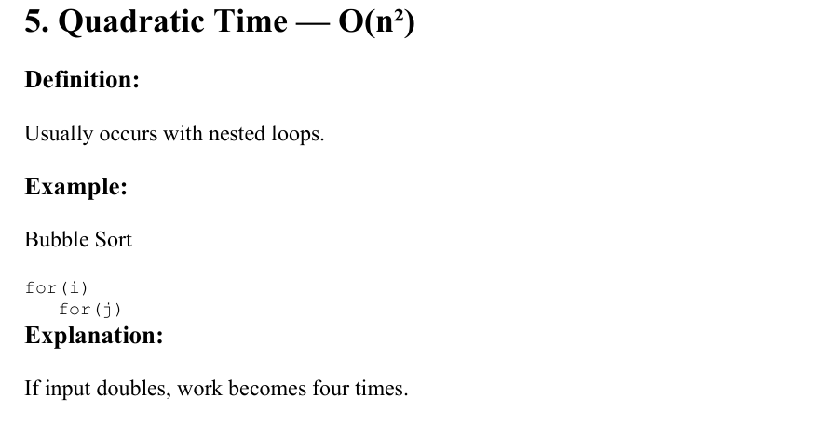
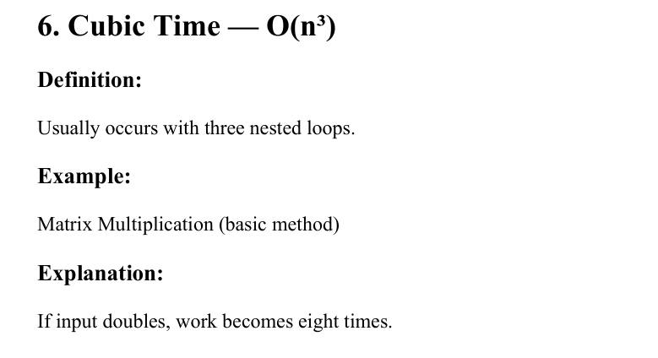
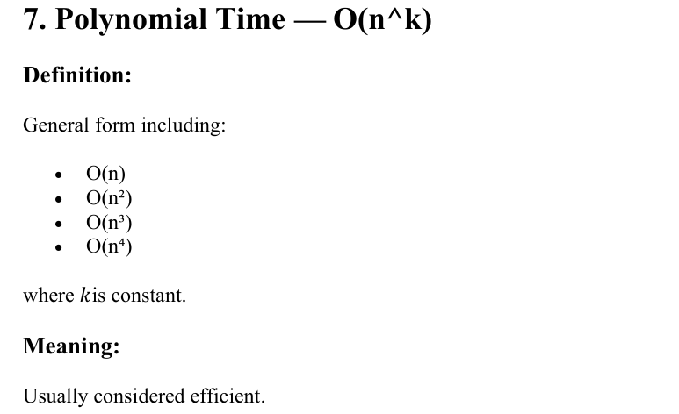
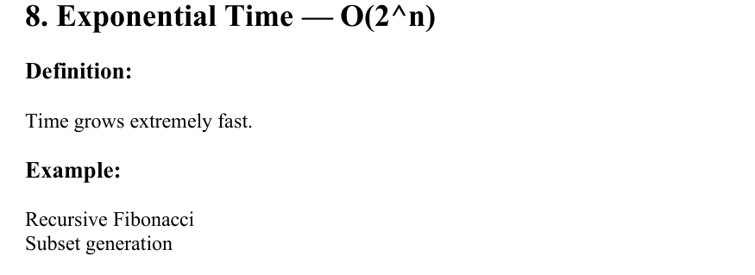
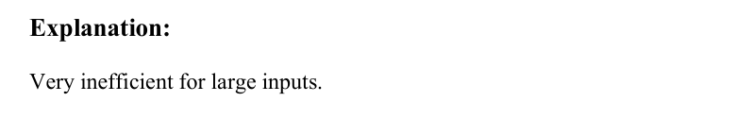
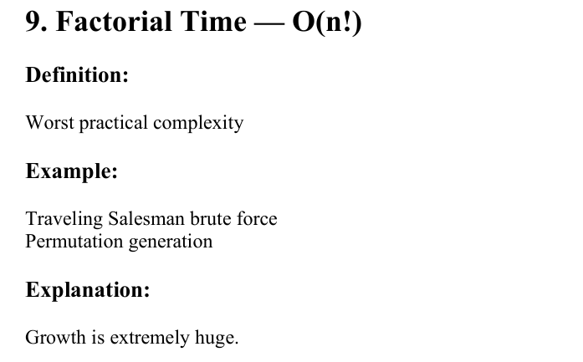
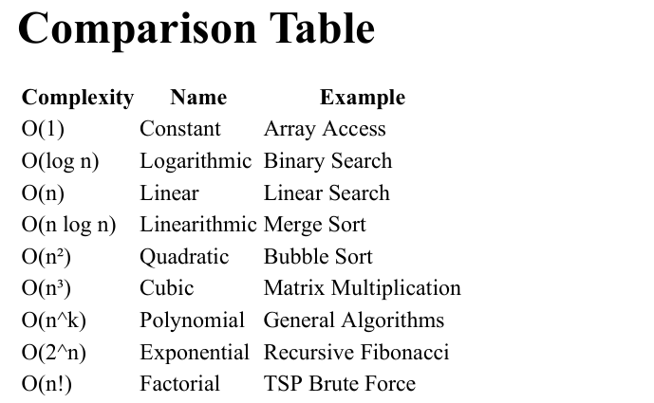
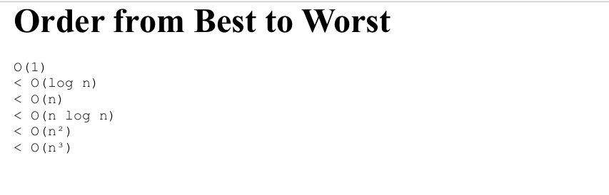
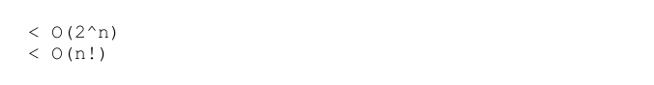

Lecture 11
Computing Time Complexity
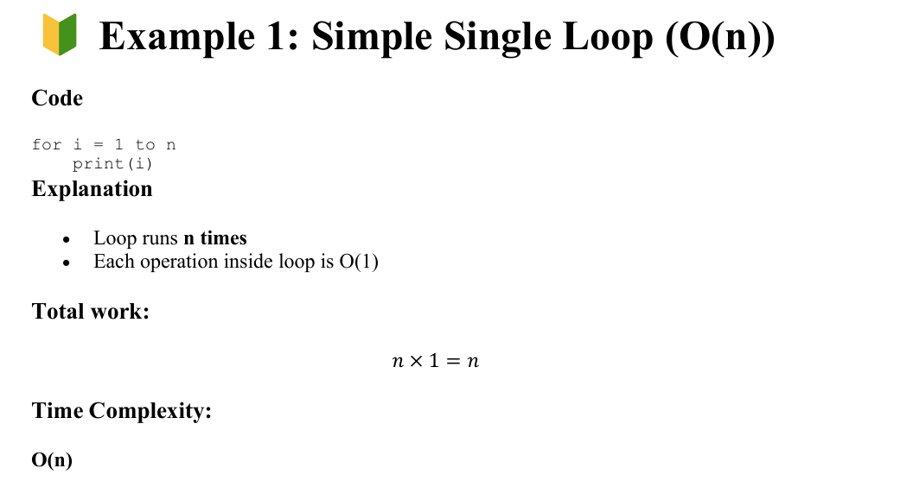
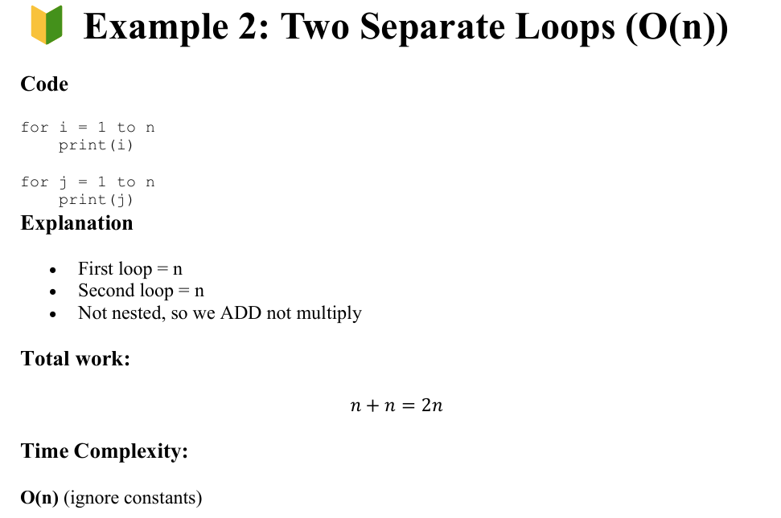
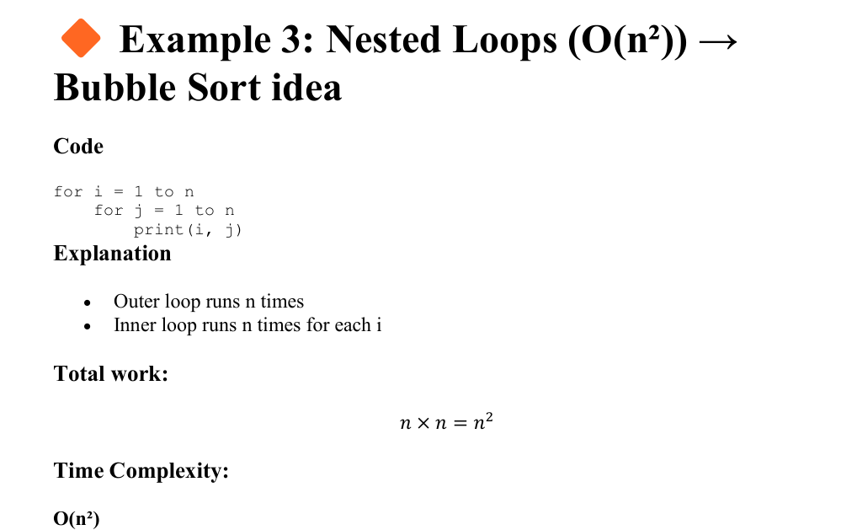
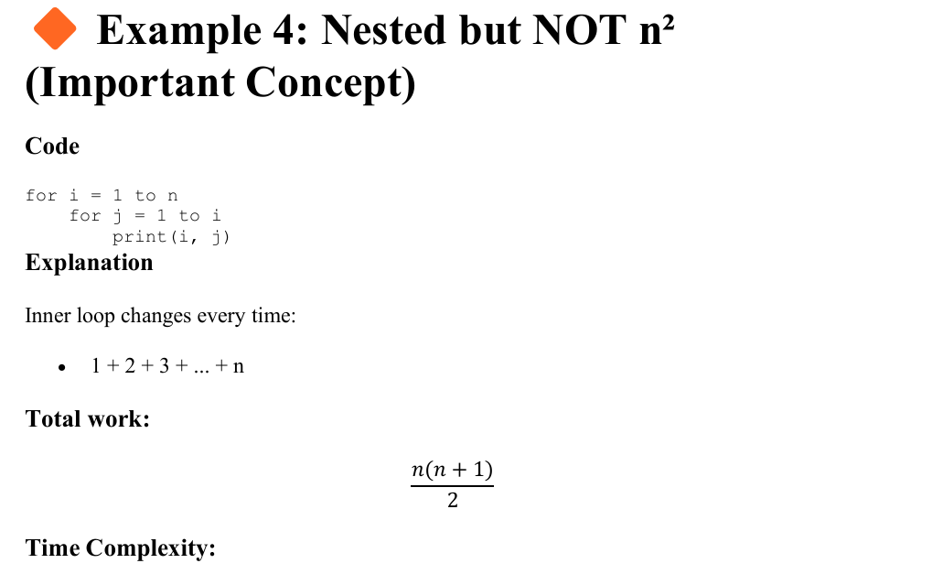
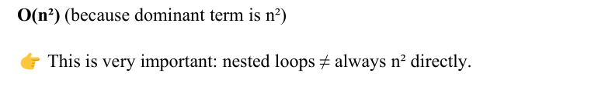
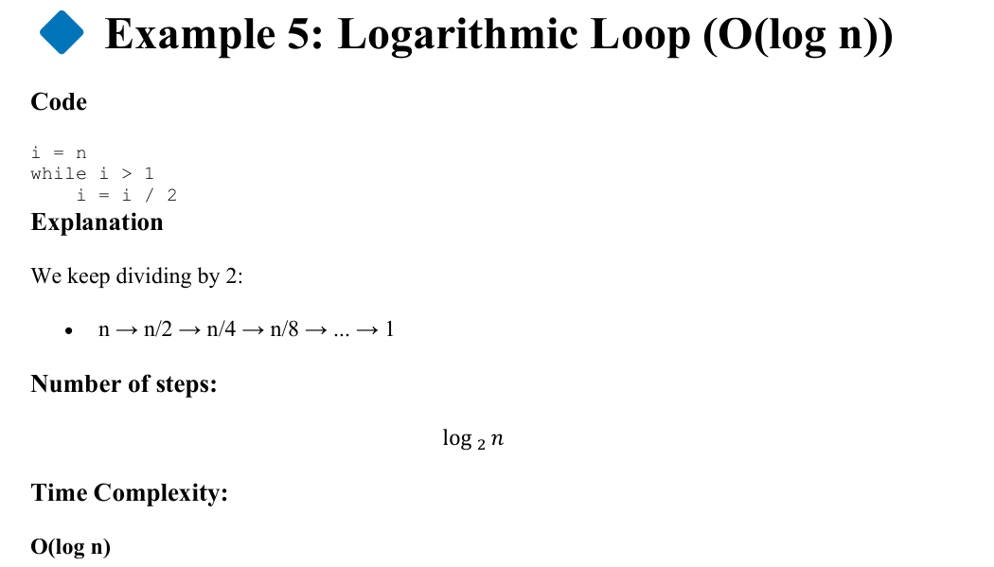
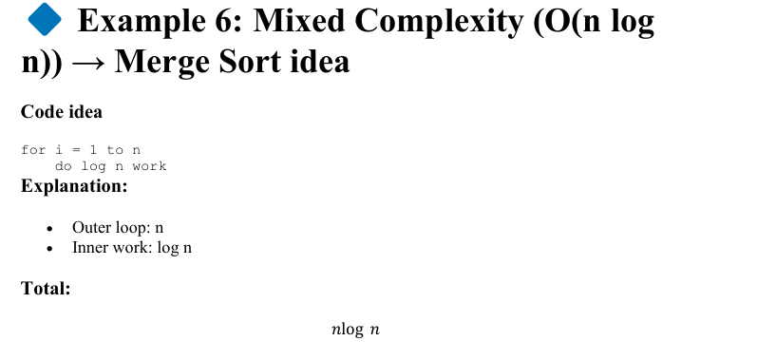
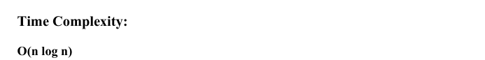

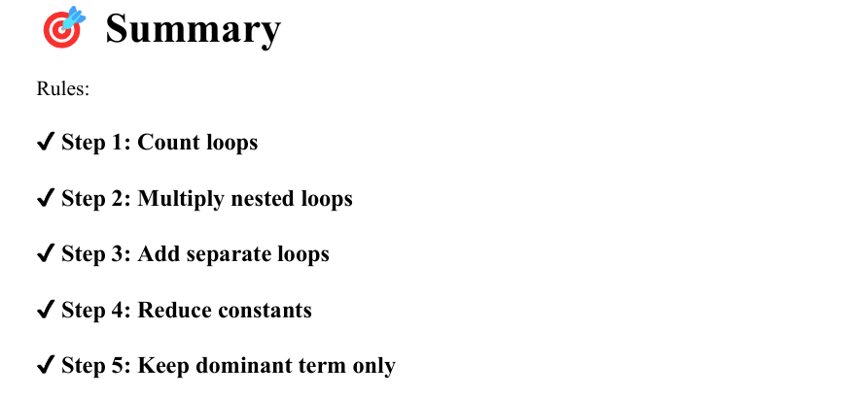
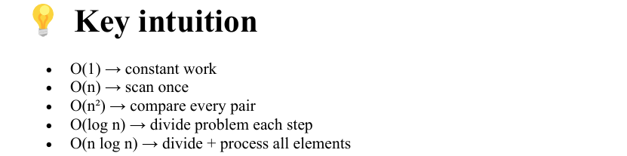
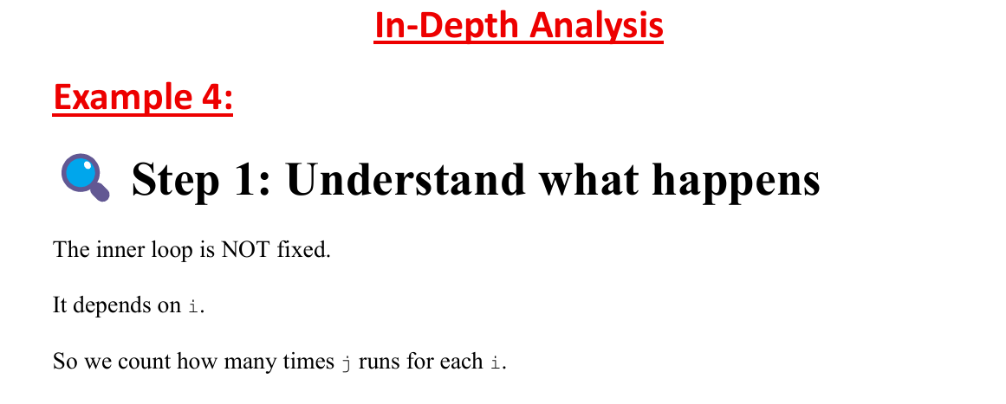
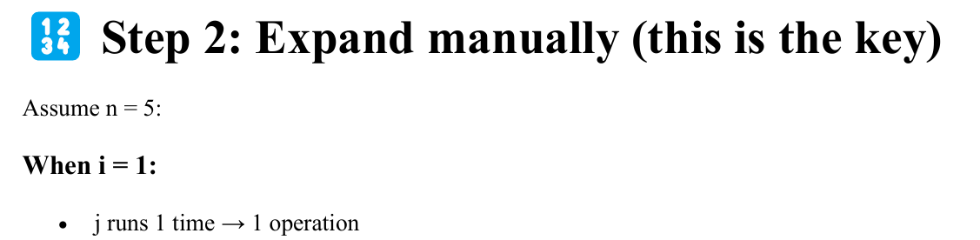
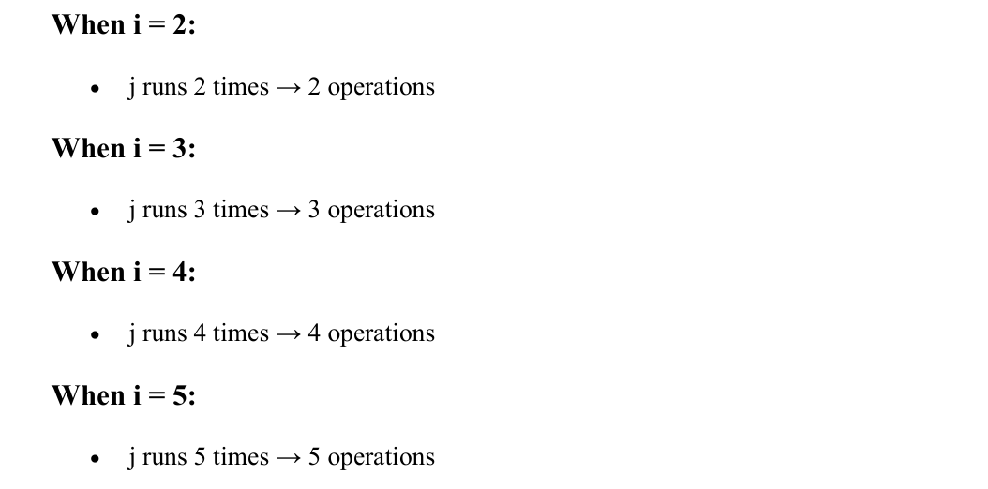
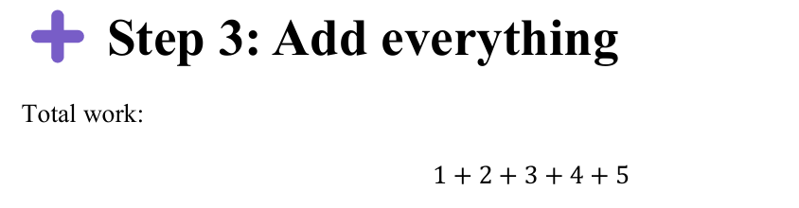
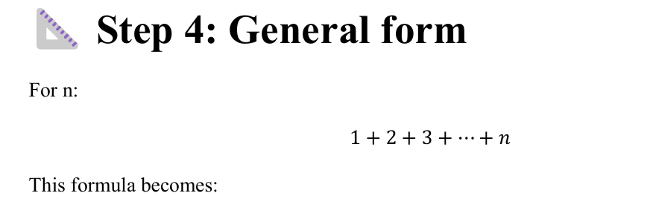

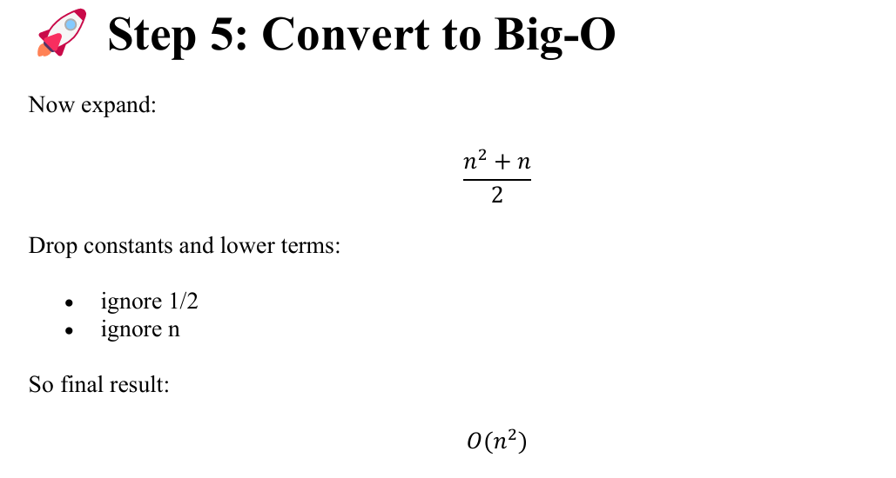
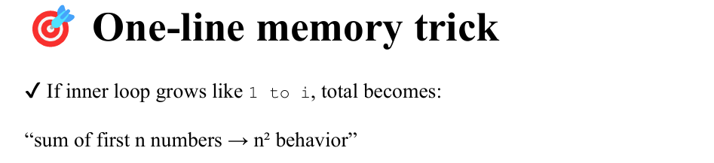
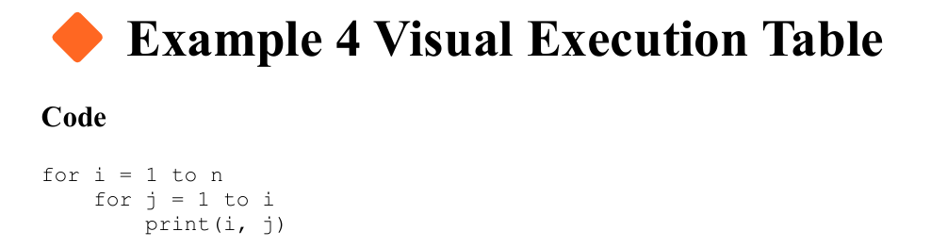
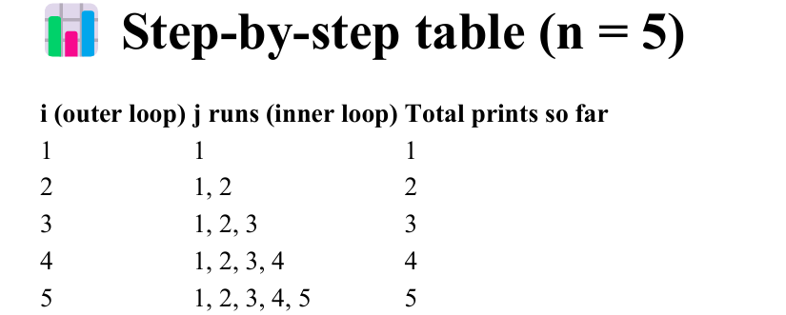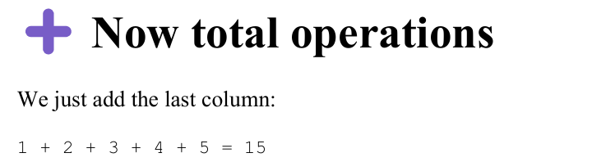

Lecture 12
Recurrence Relation
Recurrence relation
A recurrence relation is an equation that defines a problem using smaller versions of the same problem.
It is mostly used in:
- Recursion
- Divide and Conquer algorithms
- Time complexity analysis
